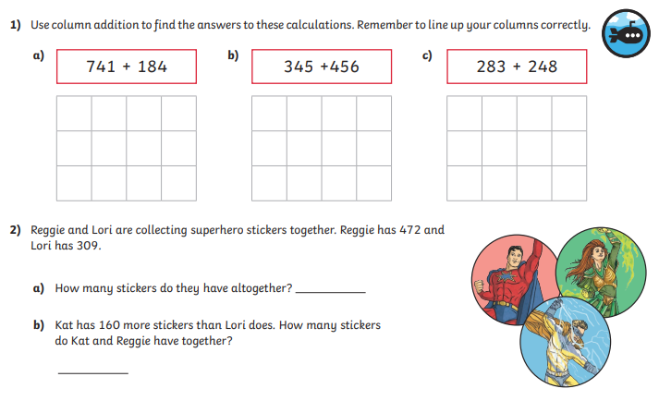
Tuesday 5th January 2021
LO: To add and subtract
C: Addition recap

Tuesday 5th January 2021
LO: To add and subtract
C: Addition recap

