LO: To understand lifestyles and practices. To understand beliefs and teachings.
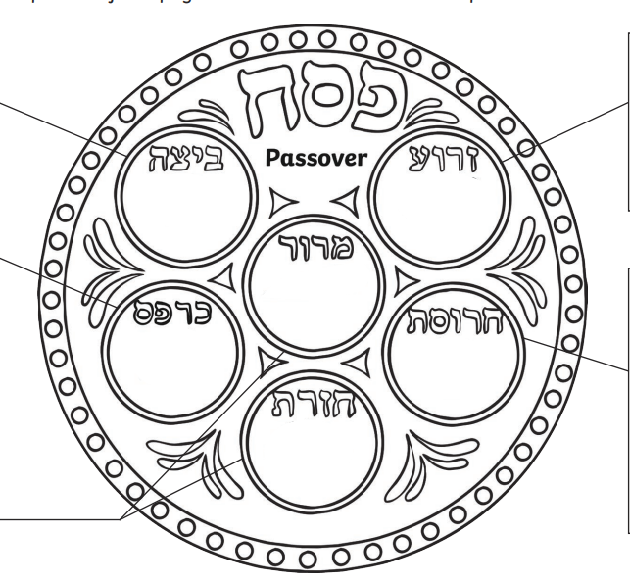
C: Passover
Cut and stick the items of the Passover meal and add the labels.

Can you think of special occasions where you have a special meal?



