
L.O. To design, make, evaluate and improve C: Carriage
Describe your carriage.
My Carriage

What do you think went well?
What would you like to change about your carriage?

Remember to use your key vocabulary.
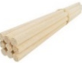  Dowel  These are long sticks that need to be cut down to use as axels in our carriages. | 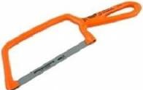  Handsaw  Only use these with an adult. We will use these to make our axels out of doweling | 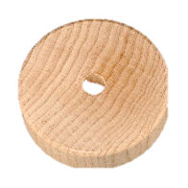  Wheel  We are using wooden wheels to make our carriages roll.
  Cardboard Box  Once covered in paper and decoraed, these will be our carriages. | Ruler  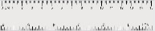  A tool to help with measuring length in centimetres. | 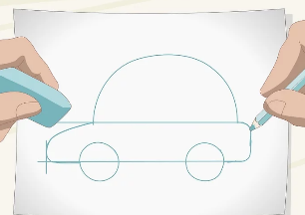  Design  A picture of what your carriage will look like.

