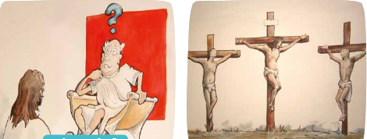
LO: To understand beliefs and teachings.
C: To describe some of the main festivals and celebrations of a religion.
Why does Easter matter to Christians?
Order the pictures and add annotations about what is happening and how Jesus would be feeling at this time.

What is the most important part of the story and why?
What is the most puzzling part of the story and why?



