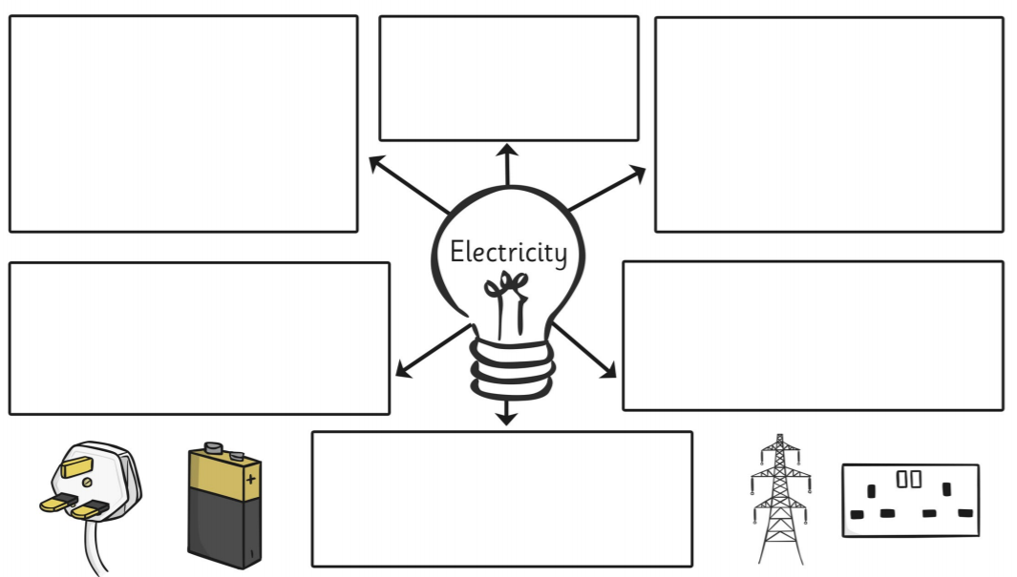
LO: To understand electrical circuits.
C: To identify common appliances that run on electricity.

