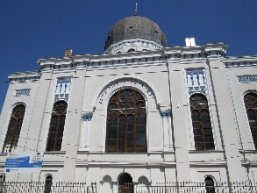  Visiting the synagogue to pray | 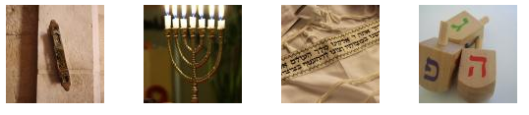  Having a tallit prayer shawl with Hebrew embroidery
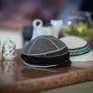  Wearing a kippah or yarlmulke, which some Orthodox Jewish men wear on their head | Playing with dreidels, a traditional Jewish game at Hannukah
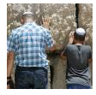  Men praying at the Western Wall in Jerusalem | 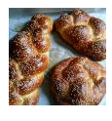  Eating challah bread, a Jewish braided bread eaten on the Sabbath and on holidays
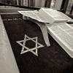  Looking at the star of David, a symbol of the Jewish people | Having a mezuzah, a symbol attached to the doorways of Jewish homes.

