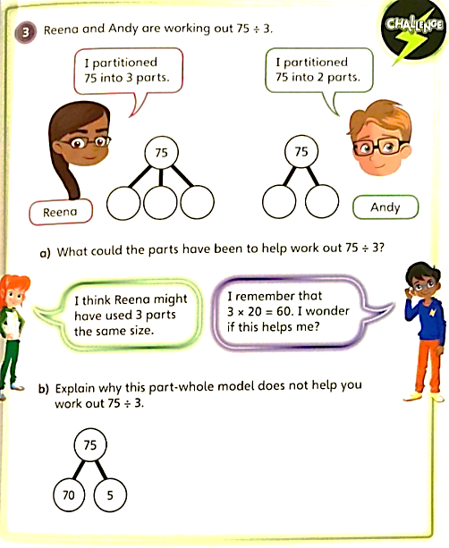

15.03.2021
L.O: Multiplication and Division
C: Divide 2-digits by 1-digit (2)
1) Solve these by drawing part whole-models:

a) 78 ÷ 6 = b) 84 ÷ 3 = c) 70 ÷ 5 = d) 96 ÷ 4 =

RP:
15.03.2021
L.O: Multiplication and Division
C: Divide 2-digits by 1-digit (2)
1) Solve these by drawing part whole-models:

a) 78 ÷ 6 = b) 84 ÷ 3 = c) 70 ÷ 5 = d) 96 ÷ 4 =

RP:

