LO: To understand beliefs and teachings. C: To describe some of the teachings of the religion.
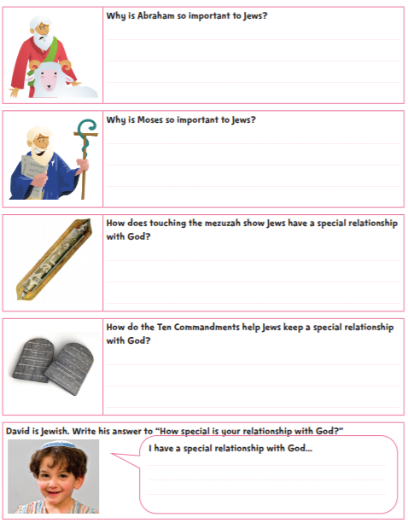
How special is the relationship Jews have with God?

