
Shark Fact File
Sharks are a type of fish but instead of having bones, their skeleton is made of cartilage. This is what your ears and the tip of your nose are made from. There are more than 500 different species of shark, including the great white shark, grey reef shark, hammerhead shark and tiger shark. Scientists believe that sharks have been in our oceans for around 455 million years. Some species of sharks prefer to live alone while others live in groups called a school or shoal.

Where do they live?
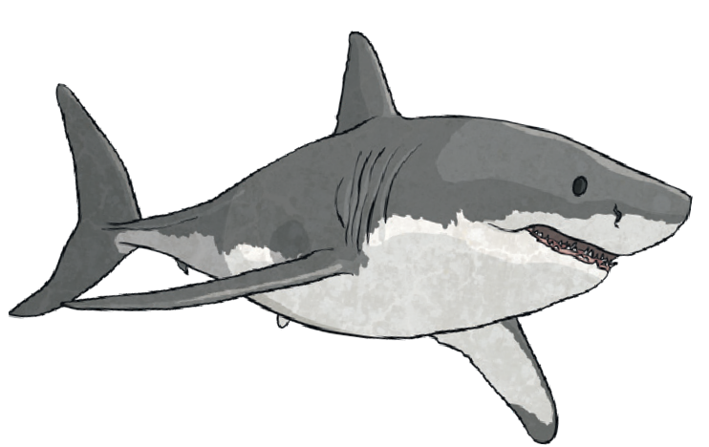
Sharks can be found in all of the Earth’s five oceans:
the Atlantic, Pacific, Indian, Arctic and Southern. Some sharks can even be found in freshwater lakes and rivers. Different species of shark live in different oceans depending on the temperature of the water. Most prefer warmer temperatures though polar sharks prefer colder water.

What do they eat?
What a shark eats depends on its species and where it lives. Most sharks are carnivores because they like to eat fish and other sharks. Some larger sharks eat dolphins, sea lions and small whales. Smaller sharks eat smaller prey such as clams, crabs and squid.

Some types of shark can be deadly, but only about 12 species have ever attacked humans. In fact, shark attacks are not very common. More people die from bee stings and natural disasters such as earthquakes and volcanoes each year than from shark attacks.

Shark Senses
Sharks have all the senses that humans have; smell, sight, touch, taste and hearing. The strongest is their sense of smell. Sharks can smell a single drop of blood in the water from 400 metres away. They can also hear fish moving from around 500 metres away. Sharks have very good eyesight and they can see in low levels of light.

Did You Know...?
Amazing Fact!
Most shark species would die if they stopped moving. As long as they keep swimming, water keeps moving over their gills, which keeps them alive.

A baby shark is called a pup.

less than 500
Sharks - Questions
1. What is a shark’s skeleton made of? Tick one.
bone muscle cartilage skin
2. How many species of shark are there? Tick one.
more than 500
less than 200
more than 700
- How long have sharks lived in our oceans?

- Name two of the world’s oceans.

- Tick whether each statement is true or false.

 | True | False
Sharks are a type of fish.
Sharks only live in seawater.
Shark attacks are very common.
Sharks have a good sense of smell.
- What are Baby Sharks called? Tick one.
pugs sharklets shells pups
- Why are sharks such good hunters? Explain your answer.



less than 500
Sharks - Answers
1. What is a shark’s skeleton made of? Tick one.
bone muscle cartilage skin
2. How many species of shark are there? Tick one.
more than 500
less than 200
more than 700
- How long have sharks lived in our oceans?

455 million years

- Name two of the world’s oceans.

Accept any two of the following: Atlantic, Pacific, Indian, Arctic, Southern

- Tick whether each statement is true or false.

 | True | False
Sharks are a type of fish. | 
Sharks only live in seawater. |  | 
Shark attacks are very common.
Sharks have a good sense of smell. | 
- What are baby sharks called? Tick one.
pugs sharklets shells pups
- Why are sharks such good hunters? Explain your answer.
Pupil’s own response, such as: Sharks are good hunters because they have a really strong sense of smell and can smell a drop of blood from 400 metres away. They can also hear fish moving from around 500 metres away and they can see in low levels of light.

Shark Fact File
Sharks are a type of fish but instead of having bones, their skeleton is made of cartilage. This is what your ears and the tip of your nose are made from. There are more than
500 different species of shark, including the great white shark, grey reef shark, hammerhead shark, tiger shark, blue shark bull shark and many others. Scientists believe that sharks have existed in our oceans for around 455 million years. Some species of sharks prefer to live alone while others live in groups called a school, shoal or shiver.
The smallest shark is the dwarf lantern shark which is usually around 17cm in length. The largest fish in the world is the whale shark, which can measure up to a massive 14 metres long.

Where do they live?
Amazing Fact!
Most shark species would die if they stopped moving.
As long as they keep swimming, water keeps moving over their gills, which keeps them alive.
Sharks can be found in all of the Earth’s five oceans:
the Atlantic, Pacific, Indian, Arctic and Southern. Some sharks can even be found in freshwater lakes and rivers. The bull and river sharks can actually live in both freshwater and seawater. Different species of shark live in different oceans depending on the temperature of the water. Most prefer warmer temperatures although polar sharks prefer colder water.

What do they eat?
What a shark eats depends on its species and where it lives. Most sharks are carnivores because they like to eat fish and other sharks. Some larger sharks eat dolphins, sea lions and small whales. Smaller sharks eat smaller prey like clams, molluscs, squid, lobster and crabs.

Although some types of shark can be deadly, only about 12 species have ever attacked humans. In fact, shark attacks are rare. More people die from bee stings and natural disasters such as earthquakes and volcanoes each year than from shark attacks.

Shark Senses
Did You Know...?
A baby shark is called a pup. They are born
already able to take care of themselves.
Sharks have all the senses that humans have; smell, sight, touch, taste and hearing. The strongest is their sense of smell. Sharks can smell a single drop of blood in the water from 400 metres away. They can also hear fish moving from around 500 metres away. Sharks have very good eyesight and they can even see well in dim light, allowing them to hunt deeper in the ocean.

- Name two species of shark.

- What is a group of sharks called? Tick one.
a pod
a lesson a school a swarm

- Fill in the missing words.
Sharks can be found in all of the earth’s five oceans: The , Pacific, Indian,
and Southern.

- Where would you most likely find polar sharks and why? Explain your answer fully.

- What word is used to describe sharks? Tick one.

herbivore carnivore omnivore vegetarian

- Which of a shark’s senses is the strongest? Tick one.

sight taste hearing smell

- From what distance can sharks hear fish moving? Tick one.
500 metres
300 metres
400 metres
50 metres

- Toby says, ‘Sharks are one of the biggest threats to humans.’ Do you agree? Yes No

Explain your answer.

- Name two species of shark.
Accept any two of the following: great white, grey reef, hammerhead and tiger.
- What is a group of sharks called? Tick one.
a pod
a lesson a school a swarm

- Fill in the missing words.
Sharks can be found in all of the earth’s five oceans: The Atlantic, Pacific, Indian,
Arctic and Southern.

- Where would you most likely find polar sharks and why? Explain your answer fully. Pupil’s own response, such as: You would most likely find polar sharks in colder oceans such as the Arctic because this species of shark prefers colder water.
- What word is used to describe sharks? Tick one.

herbivore carnivore omnivore vegetarian

- Which of a shark’s senses is the strongest? Tick one.

sight taste hearing smell

- From what distance can sharks hear fish moving? Tick one.

500 metres
300 metres
400 metres
50 metres

- Toby says, ‘Sharks are one of the biggest threats to humans.’ Do you agree? Yes No

Explain your answer.
Pupil’s own response, such as:
No, I don’t agree that sharks are one of the biggest threats because only 12 species of shark have ever attacked humans and there are over 500 species. Shark attacks are not very common and it says in the text that people are more likely to die from bee stings or natural disasters than from a shark attack.

Shark Fact File
Although a type of fish, a shark’s skeleton is made of cartilage. This is the same material that your ears and the tip of your nose are made from. There are more than 500 different species of shark, including the great white shark, grey reef shark, hammerhead shark, tiger shark, blue shark, bull shark and many others. Scientists believe that sharks have resided in our oceans for around 455 million years. Some species of sharks prefer to live alone while others live in groups called a school, shoal or shiver.

The smallest shark is the dwarf lantern shark which is usually around 17cm in length. In comparison, the largest fish in the world is the whale shark, which can measure up to a massive 14 metres long.

Where do they live?
Sharks can be spotted in all of the Earth’s five oceans: the Atlantic, Pacific, Indian, Arctic and Southern. Some sharks can even be found in freshwater lakes and rivers and the bull and river sharks can actually live in both freshwater and seawater. Different species of shark live in different oceans depending on the temperature of the water. Most prefer warmer temperatures although polar sharks prefer colder water.

What do they eat?
A shark’s diet depends on its species and where it lives. Most sharks are carnivores because they like to eat fish and other sharks. Some larger sharks eat dolphins, sea lions and small whales. Smaller sharks eat smaller prey such as clams, molluscs, squid, lobster and crabs. Sharks have many replacement teeth, which grow on the inside of their jaws and move forward when needed – a bit like a conveyor belt.

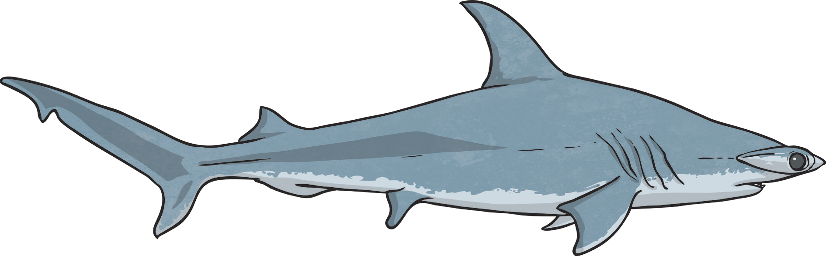
Although some types of shark can be deadly, only about 12 species have ever attacked humans. In fact, shark attacks are actually very rare. More people die from bee stings and natural disasters such as earthquakes and volcanoes each year than shark attacks.

Shark Fact File

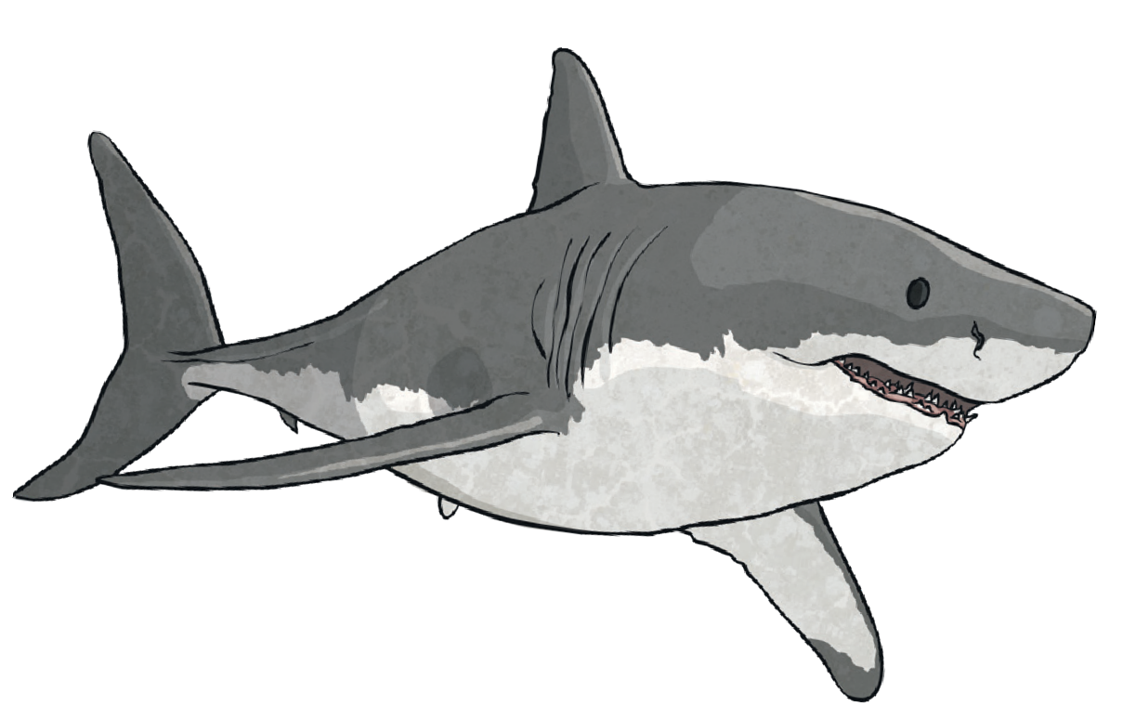

Amazing Fact!
Sharks have five to seven gill slits on the sides of their heads. As long as they keep swimming, water keeps moving over their
gills, which keeps them alive. Most shark species would die if they stopped moving.
Did You Know…?
Pups (baby sharks) are born already able to take care of themselves. They have to be able to swim away fast as some mothers try to eat their own pups and their own siblings can even attack them.

Shark Senses
Sharks have all the senses that humans have; smell, sight, touch, taste and hearing. The strongest is their sense of smell which is 10 000 times better than a human’s. Sharks can smell a single drop of blood in the water from 400 metres away. They can also hear fish moving from around 500 metres away. Sharks have very good eyesight and they can even see in very dim light which allows them to still hunt in deeper waters. As well as having incredible senses, these skilful predators can swim at great speeds; great white sharks can swim as fast as 18mph!

- Describe one way in which sharks and humans are alike.

- Which of the following is NOT a species of shark? Tick one.

hammerhead shark lion shark
grey reef shark tiger shark

- What is a ‘shoal’?

- How long is a dwarf lantern shark? Tick one.

14 centimetres
17 metres
14 metres
17 centimetres

- What is special about the bull shark and river shark? Explain your answer fully.

- Fill in the missing words.
Smaller sharks eat smaller life like clams, , squid, lobster and crabs.
- Find and copy a word that means not very common.

- Explain why sharks are such good predators. Use evidence from the text to support your answer.

- Describe one way in which sharks and humans are alike.
Pupil’s own response, such as: One way in which sharks and humans are alike is that part of their body is made of cartilage – the shark’s skeleton and the nose and ears
in a human.
- Which of the following is NOT a species of shark? Tick one.

hammerhead shark
lion shark grey reef shark tiger shark

- What is a ‘shoal’?
One name for a group of sharks.

- How long is a dwarf lantern shark? Tick one.

14 centimetres
17 metres
14 metres

17 centimetres

- What is special about the bull shark and river shark? Explain your answer fully.
Pupil’s own response, such as: The bull and river sharks are special because they can live in both freshwater, such as rivers and lakes, as well as in seawater. Most sharks live in either seawater or freshwater.
- Fill in the missing words.
Smaller sharks eat smaller aquatic life like clams, molluscs, squid, lobster and crabs.

- Find and copy a word that means not very common. rare

- Explain why sharks are such good predators. Use evidence from the text to support your answer.
Pupil’s own response, such as: Sharks are such good predators because their smell is 10,000 times better than a human’s, which means that they can smell a single drop of blood in the water from 400 metres away. They also have good hearing and eyesight which means that they can hear a fish moving from far away and they can still hunt in deeper waters. Sharks can also swim at great speeds.

