
Minibeasts
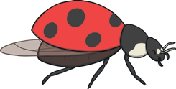

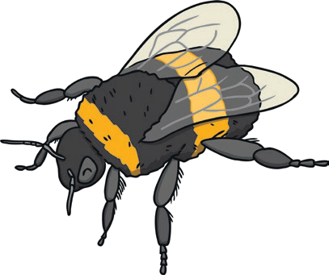

Minibeasts are animals with no backbones. You can see them all around us, such as spiders, beetles, snails, worms and butterflies.
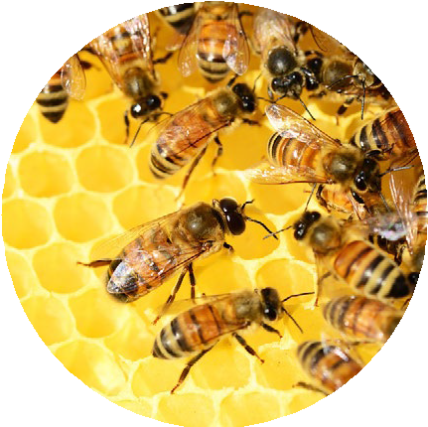

In the Garden
A garden is a great place to find minibeasts. If you look closely around flowering plants, you might see honeybees and bumblebees.

In Ponds and Rivers
Some minibeasts found near ponds or rivers can be born in water and grow so they are able to fly and live on land. You might find spiders or even dragonflies living near ponds or rivers that grow into four-winged insects that live in tall trees near water. You could see spiders too.
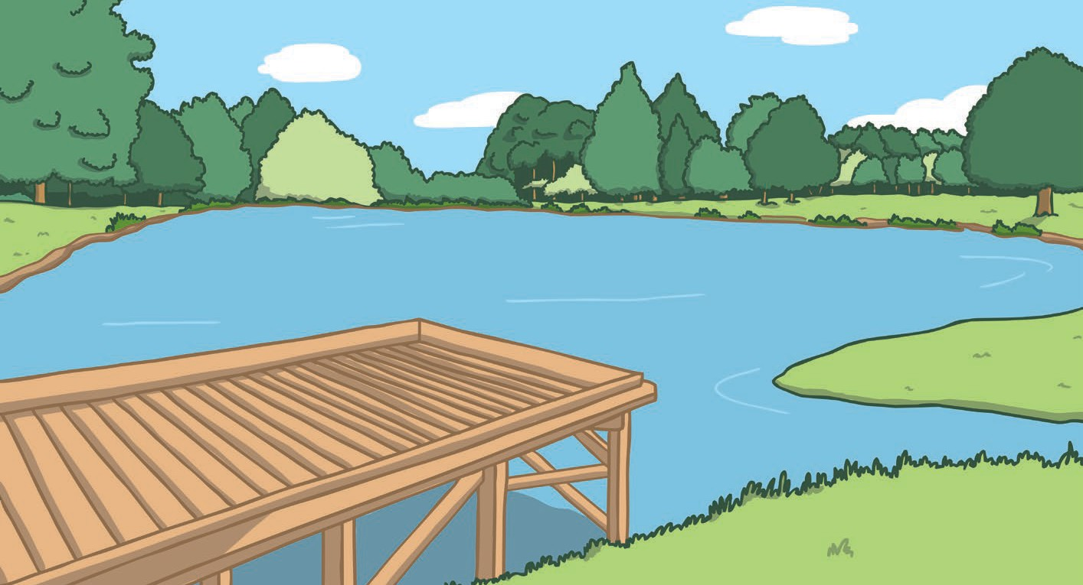
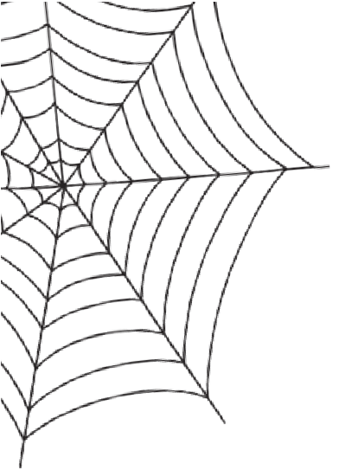
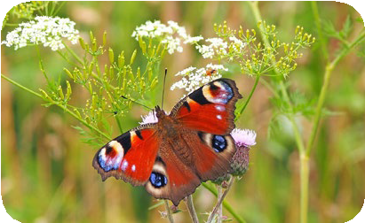
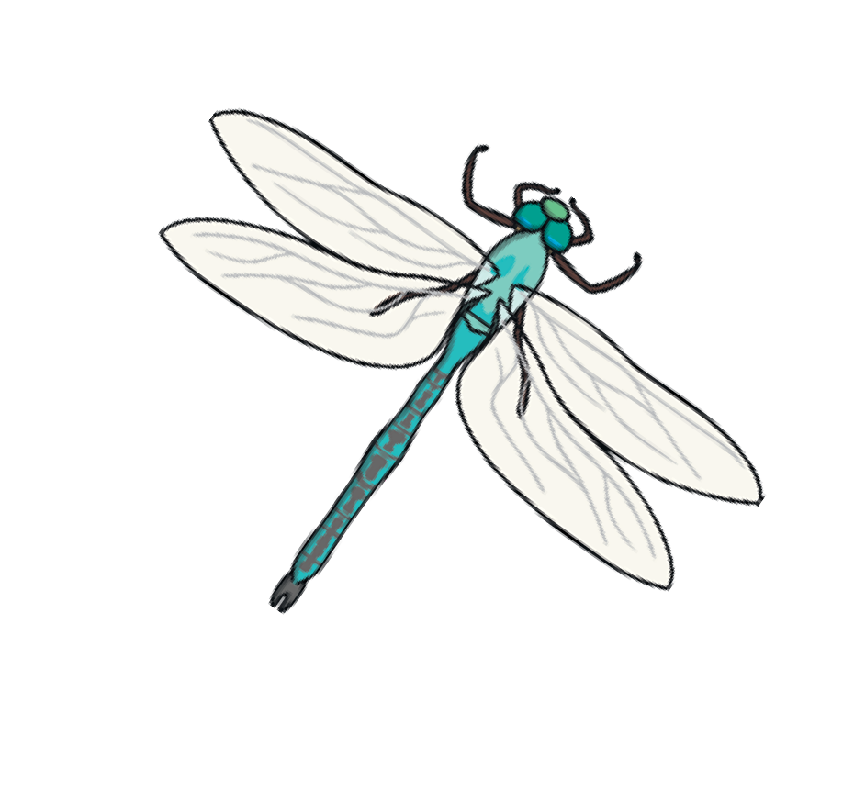
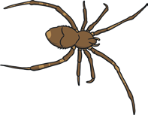
Did You Know...? A peacock butterfly has eye-shaped patterns on its wings to fool other animals who may want to eat it.

Questions
- What are minibeasts? Tick one.
 animals that have hair or fur animals with no backbones animals with no legs
- Where can you find minibeasts? Tick two. in the garden
inside the body
 in ponds and rivers

- What minibeasts can you see near flowering plants? Tick one.
worms and beetles
honeybees and bumblebees spiders and dragonflies

- Where can dragonflies live? Tick one.
underground in tall trees underwater
- Which two minibeasts might you find near a pond or river? Tick two. bumblebees
dragonflies spiders

Answers
- What are minibeasts? Tick one.

animals that have hair or fur

animals with no backbones
animals with no legs


- Where can you find minibeasts? Tick two.  in the garden
inside the body

in ponds and rivers

- What minibeasts can you see near flowering plants? Tick one.

worms and beetles

honeybees and bumblebees
spiders and dragonflies

- Where can dragonflies live? Tick one.

underground

in tall trees
underwater


- Which two minibeasts might you find near a pond or river? Tick two. bumblebees
dragonflies spiders

Minibeasts

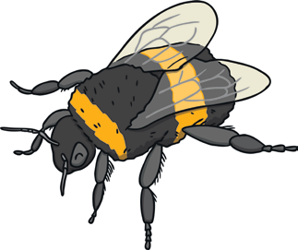
Minibeasts are a group of small creatures known as invertebrates. There are hundreds of thousands of minibeasts all around us, such as spiders, beetles, snails, worms, butterflies and many more.
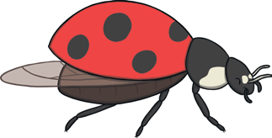
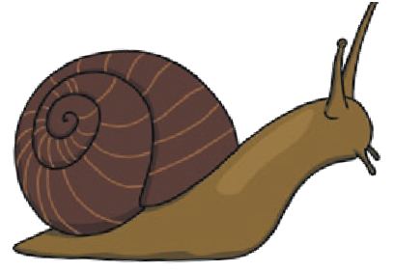
Some minibeasts have a long body and lots of legs, such as caterpillars and millipedes. Some have wings, such as butterflies and bees, while others make slime to move underground easily, such as earthworms. There are even some minibeasts that are coloured so they can hide on leaves and branches.
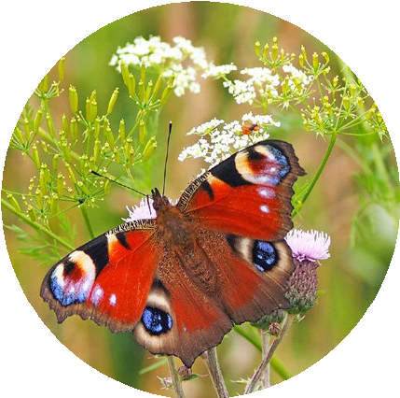

Did You Know...? A peacock butterfly has eye-shaped patterns on its wings to fool other animals
who may want to eat it.

Where Do Minibeasts Live?
Minibeasts can be found in many different habitats - under logs and rocks, in soil beneath our feet, in piles of leaves, grass, ponds, bushes, trees or even in tiny cracks in walls.

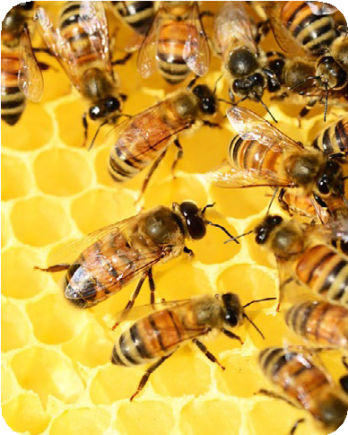

In the Garden
A garden is a great place to find minibeasts. If you look closely around flowering plants, you might see honeybees and bumblebees.
Bees are very important to the life of a garden because they move pollen, which allows plants to grow seeds and fruit.


Minibeasts

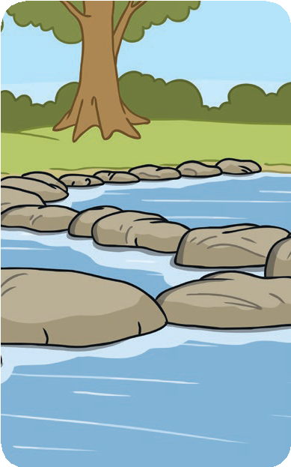

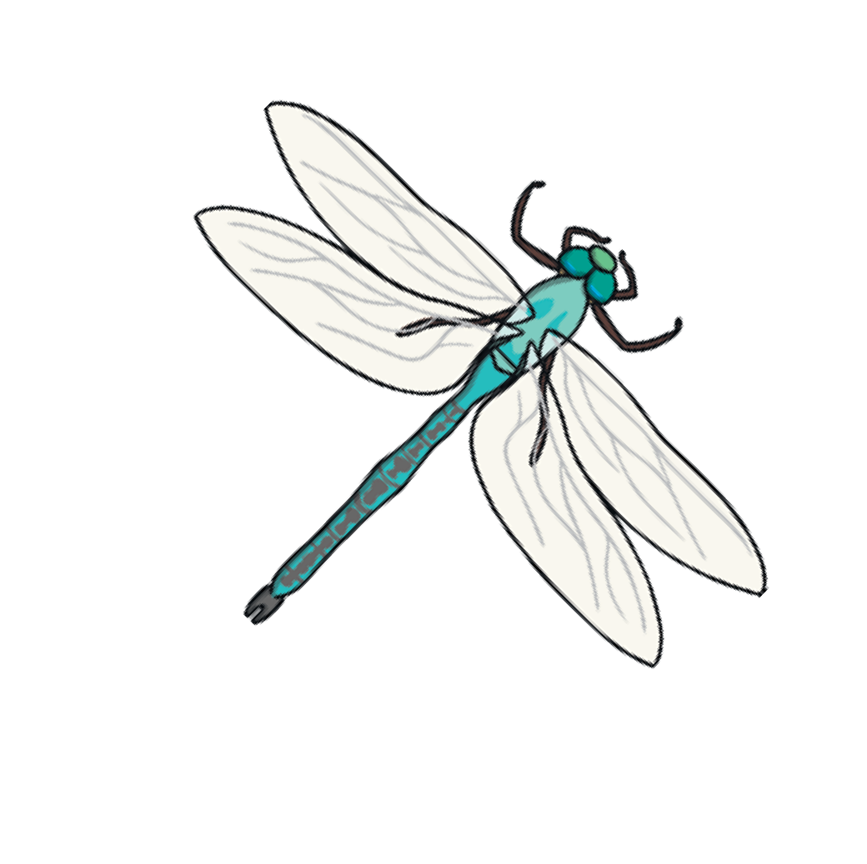
In Ponds and Rivers
Minibeasts can be found in ponds and rivers. These animals could spend their lives in or near water. Many begin their lives in water and grow to be able to fly or live on land.
You might find dragonflies or even spiders living near ponds or rivers. Dragonflies grow into four-winged insects that live in tall trees near water.

Minibeast Record Holders


Which minibeasts hold the record for being
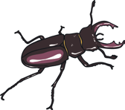
the biggest in the UK?

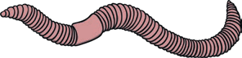


The largest stag beetle recorded was 8.5cm
long.
The largest earthworm ever recorded in the UK was 40cm long. That is the size of a small snake.

Glossary
invertebrate: A creature with no backbone.

Questions
- Draw three lines and complete each sentence.

Minibeasts are a group of ... |  | spiders, beetles, snails, worms, butterflies and many  more.
If you look closely around flowering plants, you might see ... |  | small creatures known as invertebrates.
There are hundreds of thousands of minibeasts all around us, such as ... |  | honeybees and bumblebees.

- Complete the sentences below:

Minibeasts can be found in many different - under logs and rocks, in beneath our feet, in of leaves, grass, ponds, bushes, trees or even in cracks in walls.

- What do bees move to allow plants to grow seeds and fruit?

- Where do many minibeasts that are found near ponds and rivers start life? Tick one.
in a tree
underground in water

- How many wings do dragonflies have? Tick one.
two four

six

Answers
- Draw three lines and complete each sentence.
Minibeasts are a group of ... |  | spiders, beetles, snails, worms, butterflies and many  more.
If you look closely around flowering plants, you might see ... |  | small creatures known as invertebrates.
There are hundreds of thousands of minibeasts all around us, such as ... |  | honeybees and bumblebees.
- Complete the sentences below:

Minibeasts can be found in many different habitats - under logs and rocks, in soil beneath our feet, in piles of leaves, grass, ponds, bushes, trees or even in tiny cracks in walls.

- What do bees move to allow plants to grow seeds and fruit?

pollen

- Where do many minibeasts that are found near ponds and rivers start life? Tick one.

in a tree underground in water

- How many wings do dragonflies have? Tick one.

two four six

Minibeasts
Minibeasts are a group of small creatures known as invertebrates. There are hundreds of thousands of minibeasts all around us, such as spiders, beetles, snails, worms, butterflies and many more. In fact, there are around 25,000 different types living in the UK.
Some minibeasts have a long body and lots of legs, such as caterpillars and millipedes. Some have wings, such as butterflies and bees, while others make slime to move underground easily, such as earthworms. There are even some minibeasts that are coloured so they can hide on leaves and branches.
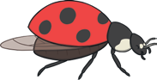
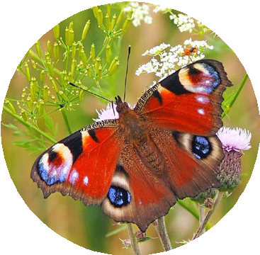

Did You Know...? A peacock butterfly has adapted eye-shaped patterns on its wings to fool predators who
might want to eat it.

Where Do Minibeasts Live?
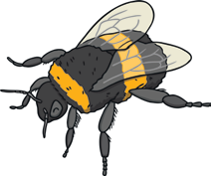
Minibeasts can be found in many different habitats - under logs and rocks, in soil beneath our feet, in piles of leaves, grass, ponds, bushes, trees or even in tiny cracks in walls.

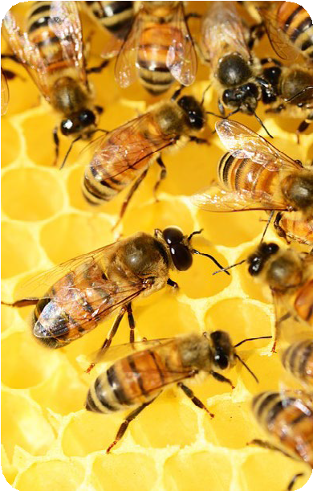

In the Garden
A garden is a great place to find minibeasts. If you look closely around flowering plants, you might see honeybees and bumblebees.
Bees are very important to the life of a garden. They collect nectar to make honey by hopping from flower to flower and they also collect and move pollen which allows plants to grow seeds and fruit.

Minibeasts

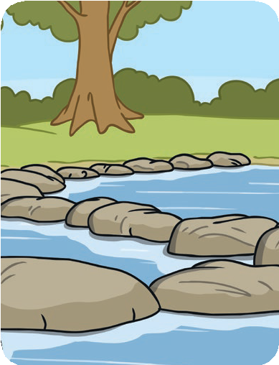

In Ponds and Rivers
Minibeasts can be found in ponds and rivers. These creatures can spend their lives in or near water, starting out as larvae born in water which grow to be able to fly or live on land. You might find dragonflies or even spiders living near ponds or rivers.

Minibeast Record Holders
Which minibeasts hold the record for being the biggest in the UK? Minibeasts come in so many different shapes and sizes. If a garden or park has a hedge around it, you might be lucky enough to find a stag beetle. The largest stag beetle recorded in the UK was 8.5cm long.
The largest earthworm ever discovered in the UK was 40cm long. That is the size of a small snake. His name was Dave and he is kept in the Natural History Museum.


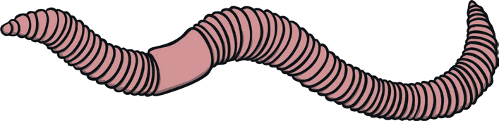

Glossary
invertebrate: A creature with no backbone. larvae: A baby invertebrate.
adapted: Changed over time.
predators: An animal that hunts and eats other animals for food.

- What are invertebrates?

Questions

- Complete the sentences below:
Some have a long body and lots of legs, such as caterpillars and millipedes. Some have wings, such as and bees, while others make slime to move easily, such as earthworms. There are even some minibeasts that are
so they can hide on leaves and branches.

- Find and copy a word that means 'a place an animal or plant would live'.

- Draw four lines and complete each sentence.

Bees are very important ... |  | different shapes and sizes.
You might find dragonflies or even spiders living ... |  | different habitats - under logs and rocks, in soil beneath our feet, in piles of leaves, grass, ponds, bushes, trees or even in tiny cracks in walls.
Minibeasts come in so many ... |  | to the life of a garden.

Minibeasts can be found in many ... |  | near ponds or rivers.

- What is the record for the biggest stag beetle found in the UK? Tick one.
9.5cm 7.5cm 8.5cm

- Sum up how some minibeasts change during their lives.

- What are invertebrates?

Answers

Invertebrates are creatures with no backbones.

- Complete the sentences below:
Some minibeasts have a long body and lots of legs, such as caterpillars and millipedes. Some have wings, such as butterflies and bees, while others make slime to move underground easily, such as earthworms. There are even some minibeasts that are coloured so they can hide on leaves and branches.

- Find and copy a word that means 'a place an animal or plant would live'.

habitat

- Draw four lines and complete each sentence.

Bees are very important ... |  | different shapes and sizes.
You might find dragonflies or even spiders living ... |  | different habitats - under logs and rocks, in soil beneath our feet, in piles of leaves, grass, ponds, bushes, trees or even in tiny cracks in walls.
Minibeasts come in so many ... |  | to the life of a garden.

Minibeasts can be found in many ... |  | near ponds or rivers.

- What is the record for the biggest stag beetle found in the UK? Tick one.

9.5cm 7.5cm 8.5cm

- Sum up how some minibeasts change during their lives.

Pupils’ own responses, such as: Some minibeasts start out as larvae in the water but live on land when they grow up.

