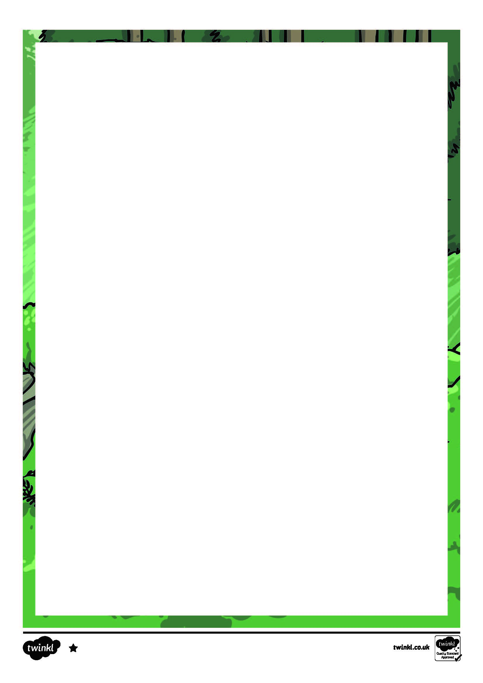
No milk for hedgehogs!
Milk makes hedgehogs very poorly so don’t leave it out for them.

Hedgehog Habits
Hedgehogs visit a lot of gardens. You could have as many as 10 different hedgehogs passing through your garden! They are very nosey animals, and sometimes need rescuing from getting their heads stuck in empty yoghurt pots, tins and plastic cups.

What do they look like?
Hedgehogs are small, spiky animals. Their babies are called hoglets. Adult hedgehogs have long spines along their backs and sides, but not on their faces or legs. Some hedgehogs can have up to seven thousand spines!
What do they eat?
Hedgehogs are often called the Gardener’s Friend because they eat the slugs that eat plants and cause damage to the garden. Gardeners are usually pleased to see a hedgehog.
If you want a hedgehog to visit your garden, you could leave a small saucer of cat or dog food out as they like the meat. Make sure that you leave a saucer of water out too, especially in the summer months.
Hedgehogs can be found almost everywhere in the UK. They live in cities and towns, and can be found on railway land, parks and gardens. They do not live on mountainsides because there is not much food for them and there are not many places for them to nest.

Hedgehogs

Nesting places – Hedgehogs nest in piles of leaves, so if you are planning to tidy the garden, be careful you don’t accidentally wake a sleeping hedgehog.

hibernate – to sleep all through the cold winter months until the springtime.
slug pellets – poisonous tablets left out in the garden to kill slugs.

Hedgehogs hibernate between November and the middle of March, so be extra careful if moving piles of leaves during this time.

Slug pellets – Never use these to kill slugs. Hedgehogs eat the pellets or the dead slugs and the poison in them can kill the hedgehogs.
Garden ponds – Hedgehogs can fall into ponds and drown. Make sure your pond has sloping sides so a hedgehog can get out to safety if they fall in. You could also cover the pond with netting or chicken wire.
Helping a Hedgehog
There are some things you can do to keep a visiting hedgehog safe if they pass through your garden.

When a hedgehog feels scared, it will roll itself up into a ball so that its spikes will frighten off its enemies.


- Name two places hedgehogs can live.

- What are hoglets?

- Why would a gardener want to have a hedgehog in their garden?

- Why do you think the author says you should leave a saucer of water out for them ‘especially in the summer months’?

- What does the hedgehog use to frighten off its enemies?

- Why should you not use slug pellets in the garden?

- Where do hedgehogs like to nest?

- What would you expect a hedgehog to be doing at the beginning of March?
Answer the following questions in as much detail as you can and in full sentences.

Hedgehogs Questions

- Name two places hedgehogs can live.
Any of the following two places: cities, towns, railway land, parks and/or gardens.
- What are hoglets?
Hoglets are baby hedgehogs.
- Why would a gardener want to have a hedgehog in their garden?
A gardener would want a hedgehog in their garden because they eat slugs that can damage their plants.
- Why do you think the author says you should leave a saucer of water out for them ‘especially in the summer months’?
You should leave a saucer of water out ‘especially in the summer months’ because it can get hot and the hedgehogs will need a drink.
- What does the hedgehog use to frighten off its enemies?
The hedgehog uses its spikes to frighten off its enemies.
- Why should you not use slug pellets in the garden?
You should not use slug pellets in the garden because hedgehogs might eat them or the dead slugs and then could die because the pellets can make the hedgehog very poorly.
- Where do hedgehogs like to nest?
Hedgehogs like to nest in piles of leaves.
- What would you expect a hedgehog to be doing at the beginning of March?
I would expect a hedgehog to be hibernating (sleeping) at the beginning of March.

Hedgehogs Answers

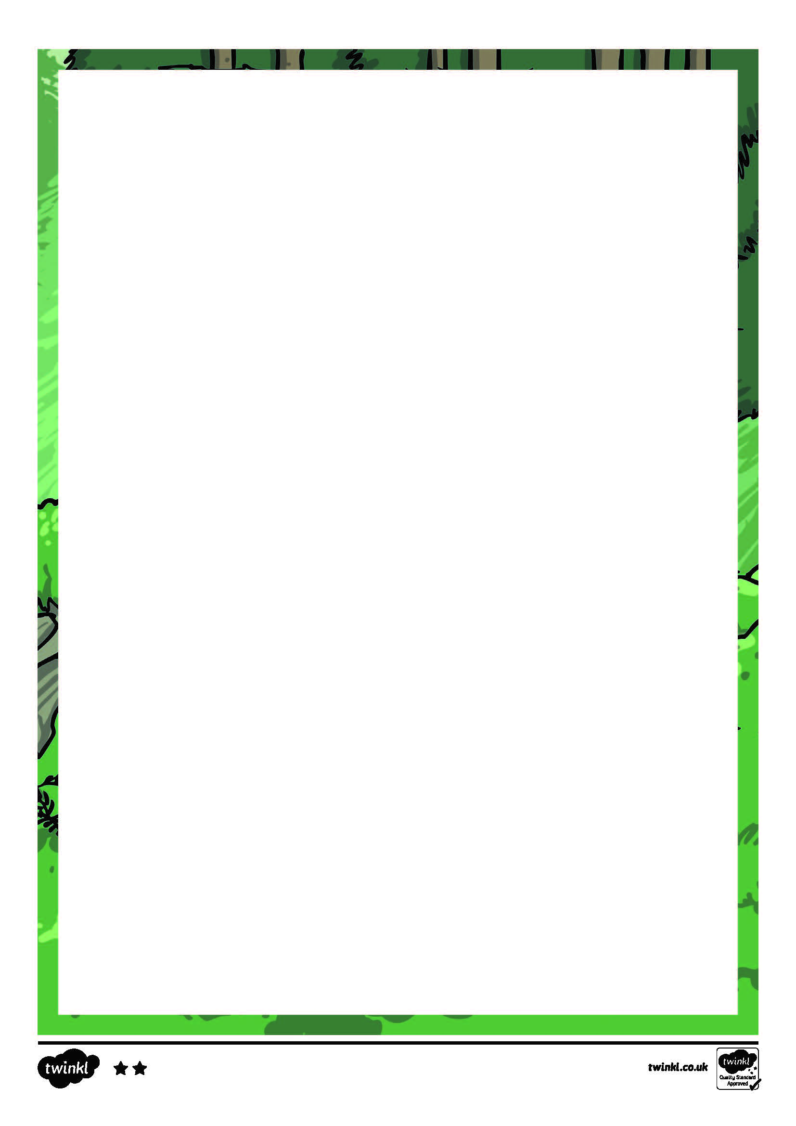
No milk for hedgehogs!
You should not leave milk out for hedgehogs because they cannot digest the lactose within it and they can become very poorly.

Did you know?
Hedgehogs also have a very small tail.

What do they look like?
Hedgehogs are small, spiky mammals. They give birth to young called hoglets. Adult hedgehogs have 25mm long spines along their backs and sides, but not on their faces or legs. Here, they are covered in tough, brown fur. They usually have between five thousand and seven thousand spines!
What do they eat?
Hedgehogs are often called the Gardener’s Friend because they eat slugs and beetles. Slugs damage plants so gardeners are often pleased to see a hedgehog in their garden. They also eat earthworms.
To improve the chance of a hedgehog visiting your garden, you could leave a small saucer of cat or dog food out as they like the meat. Make sure you leave a saucer of water out too, especially in the summer months.
Hedgehogs can be found almost everywhere in the UK. They are able to live in cities and towns, and can commonly be found on railway land as well as wastelands and gardens. They do not live on mountainsides or wet areas because there is not much food for them and there are less areas for them to nest.

Hedgehogs

Helping a Hedgehog
There are some things you can do to keep a visiting hedgehog safe if they pass through your garden.
Slug pellets – Never use these to kill slugs. Hedgehogs eat the pellets or the dead slugs and the poison in them can kill the hedgehogs.
Garden ponds – Hedgehogs can fall into ponds and drown. Make sure your pond has sloping sides so a hedgehog can scramble out to safety if they fall in. You could also cover the pond with netting or chicken wire.
Drains – Keep drains covered to stop the hedgehogs falling in and getting stuck.
Shed doors – Keep shed doors closed so a hedgehog doesn’t wander in and get locked in overnight.
When a hedgehog feels threatened it will roll itself up into a ball so that it’s spikes will act as a defence against enemies.

Hedgehog Habits
Hedgehogs often visit a lot of gardens. You might think you are seeing the same hedgehog, but you could have as many as 10 different hedgehogs passing through your garden!
They are very nosey animals and sometimes need rescuing from getting their head stuck in empty yoghurt pots, tins and plastic cups.
Hedgehogs hibernate between November and the middle of March so be extra careful if moving piles of leaves during this time.

Nesting places – Hedgehogs nest in piles of leaves, so if you are planning to tidy the garden, be careful you don’t accidentally wake a sleeping hedgehog.


- Give two reasons why hedgehogs don’t live on mountainsides.

- Where do hedgehogs not have spikes?

- In detail, explain why a gardener might be pleased to see a hedgehog in their garden.

- What could you leave out for a visiting hedgehog?

- Why should you not give them milk?

- Why might a hedgehog need rescuing from an empty yoghurt pot?

- What other word could the author have used instead of ‘threatened’?

- What problem might a hedgehog have with a garden pond and how can you help keep them safe?

- Why do you need to be careful if moving piles of leaves in November, in the garden?

Hedgehogs Questions

Answer the following questions in as much detail as you can and in full sentences.

- Give two reasons why hedgehogs don’t live on mountainsides.
Hedgehogs don’t live on mountainsides because there is not much food for them and there are less areas for them to nest.
- Where do hedgehogs not have spikes?
Hedgehogs do not have spikes on their face or their legs.
- In detail, explain why a gardener might be pleased to see a hedgehog in their garden?
A gardener might be pleased to see a hedgehog in their garden because they eat slugs that damage garden plants.
- What could you leave out for a visiting hedgehog?
You could leave out a saucer of cat or dog food and a saucer of water for a visiting hedgehog.
- Why should you not give them milk?
You should not give them milk because they cannot digest the lactose within it and it makes them poorly.
- Why might a hedgehog need rescuing from an empty yoghurt pot?
A hedgehog might need rescuing from an empty yoghurt pot because they are nosey and might have put their head in to have a look and got stuck.
- What other word could the author have used instead of ‘threatened’?
The author could have used these words for threatened: frightened, scared, in danger or afraid.
- What problem might a hedgehog have with a garden pond and how can you help keep them safe?
Hedgehogs might fall into a garden pond and drown. You can help keep them safe by having sloping sides to the pond or covering it with netting or chicken wire.
- Why do you need to be careful if moving piles of garden leaves in November?
You need to be careful if moving piles of garden leaves in November because hedgehogs might be hibernating in them.

Hedgehogs Answers

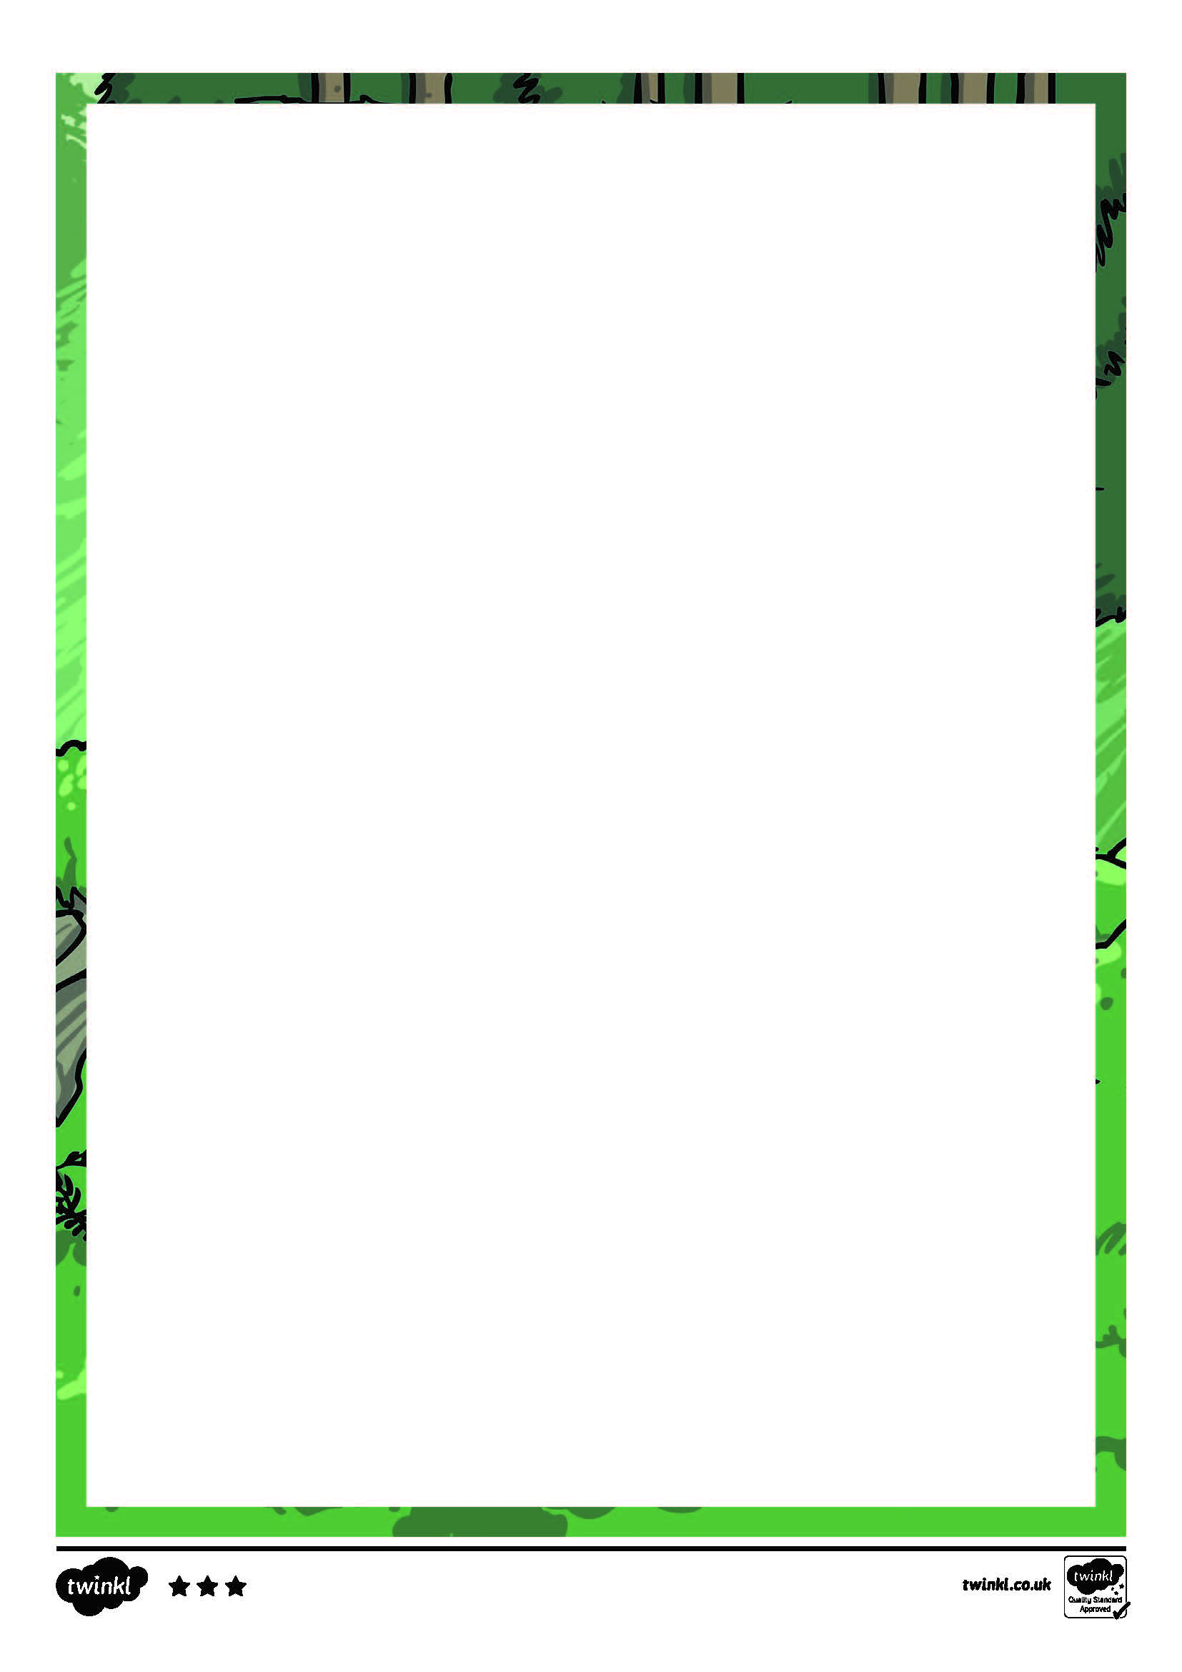
When a hedgehog feels threatened, it will roll itself up into a ball so that it’s spikes will act as a defence against enemies.

What do they look like?
Hedgehogs are small, spiky mammals. They give birth to live young called hoglets. Adult hedgehogs are covered in 25mm long spines along their backs and sides, but not on their faces, chest or legs. Here, they are covered in tough, brown fur. They usually have between five thousand and seven thousand spines!
What do they eat?
Hedgehogs are often called the ‘Gardener’s Friend’ because they eat slugs and beetles. Slugs damage plants so gardeners are often pleased to see a hedgehog in their garden. They also eat earthworms.
If you wanted to encourage a hedgehog to visit your garden, you could leave a small saucer of cat or dog food out as they like the meat. Make sure you leave a saucer of water out too, especially in the summer months.
Did you know?
Hedgehogs also have a very small tail.

Hedgehogs can be found almost everywhere in the UK. They have become comfortable living in cities and towns, and are known to make good use of cemeteries, railway land as well as wastelands and gardens. The only places they are not as happy living in are on mountainsides or wet areas because food is scarce and there are less areas for them to nest.

Hedgehogs

sides to the pond so a hedgehog can scramble out to safety if they fall in. You could also cover the pond with netting or chicken wire.
Drains – Keep drains covered to prevent the hedgehogs falling in and getting stuck.
Garden ponds – Hedgehogs have been known to fall into ponds and drown. You could help by having sloping

Helping a Hedgehog
There are some things you can do to keep a visiting hedgehog safe if they visit your garden.
Slug pellets – Never use these to kill slugs. Hedgehogs eat the pellets or the dead slugs and the poison in them can kill the hedgehogs.
Hedgehogs hibernate between November and the middle of March so be extra careful if moving piles of leaves during this time.

Hedgehog Habits
Hedgehogs tend to visit quite a number of gardens. You might think you are seeing the same hedgehog, but chances are you could have as many as 10 different hedgehogs passing through your garden!
They are very inquisitive animals, and have been known to need rescuing from getting their head stuck in empty yoghurt pots, tins and plastic cups.
It’s a myth!
Many people think they should leave milk and bread out for hedgehogs, but this can be very dangerous for the little creatures. This is because they cannot digest the lactose in the milk, which can make them very poorly.

Shed doors – Keep shed doors closed so a hedgehog doesn’t wander in and get locked in overnight.
Nesting places – Hedgehogs nest in piles of leaves, so if you are planning to tidy the garden, be careful that you don’t accidentally disturb a sleeping hedgehog.

- Where are you not likely to find hedgehogs? Why?

- Which word does the author use to tell us that food might not be found in these places?

- Why are hedgehogs called Gardener’s Friends?

- Describe two things we can do if we want hedgehogs to come to our gardens.

- Which word does the author use to tell us that hedgehogs are nosey or interested in what they can find?

- What do people mistakenly give hedgehogs to eat and why is this not a good idea?

- Explain why hedgehogs roll into a ball.

- What kind of food and drink should we leave out for hedgehogs and why?

- Why do people need to take care around November to March?
Answer the following questions in as much detail as you can and in full sentences.

Hedgehogs Questions

- Where are you not likely to find hedgehogs? Why?
You are likely not to find hedgehogs on mountainsides or wet places because food is scarce and there aren’t many areas for them to nest.
- Which word does the author use to tell us that food might not be found in these places?
The word the author uses that tells us that food might not be found in these places is ‘scarce’.
- Why are hedgehogs called Gardener’s Friends?
Hedgehogs are called Gardener’s Friends because they eat slugs and beetles. This is useful because slugs damage the plants.
- Describe two things we can do if we want hedgehogs to come to our gardens.
Any two of the following: don’t use slug pellets, keep garden ponds covered and with sloping sides, keep drains covered, keep shed doors shut, and be careful in nesting places.
- Which word does the author use to tell us that hedgehogs are nosey or interested in what they can find?
The word that the author uses to tell us that hedgehogs are nosey or interested in what they can find is ‘inquisitive’.
- What do people mistakenly give hedgehogs to eat and why is this not a good idea?
People mistakenly give hedgehogs milk. This is not a good idea because they cannot digest the lactose in milk so it can make them poorly.
- Explain why hedgehogs roll into a ball.
Hedgehogs roll into a ball if they feel threatened and to defend themselves against enemies.
- What kind of food and drink should we leave out for hedgehogs and why?
We can put out cat or dog food because they like meat and a saucer of water especially during the summer months.
- Why do people need to take care around November to March?
People need to take care around November to March because hedgehogs hibernate then and they might be under a pile of leaves asleep.

Hedgehogs Answers

