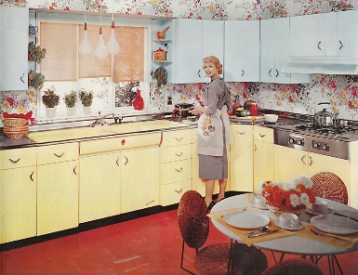 | milkman | a light afternoon meal consisting typically of tea to drink, sandwiches, and cakes.
 | tiger | a room or area where food is prepared and cooked.
 | sandwich | A word someone uses to describe their father.
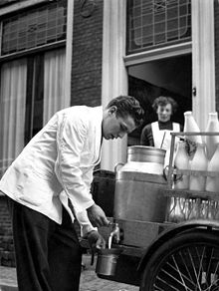 | Mummy | an item of food consisting of two pieces of bread with meat, cheese, or other filling between them, eaten as a light meal.
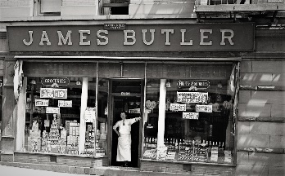 | grocer | a person who delivers and sells milk.
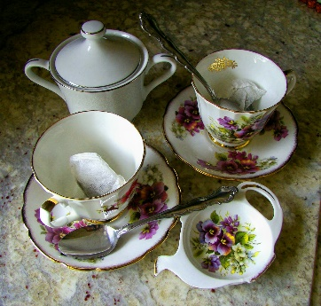 | kitchen | A very large solitary cat with a yellow-brown coat striped with black, native to the forests of Asia but becoming increasingly rare.
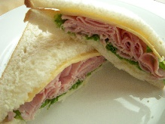 | daddy | a person who sells food and small household goods.
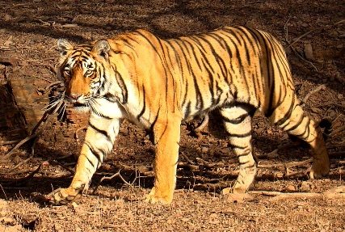 | tea | A word someone uses to describe their mother.

