LO: To understand movement, forces and magnets.
C: Notice and describe how things move using simple comparisons such as faster and slower.
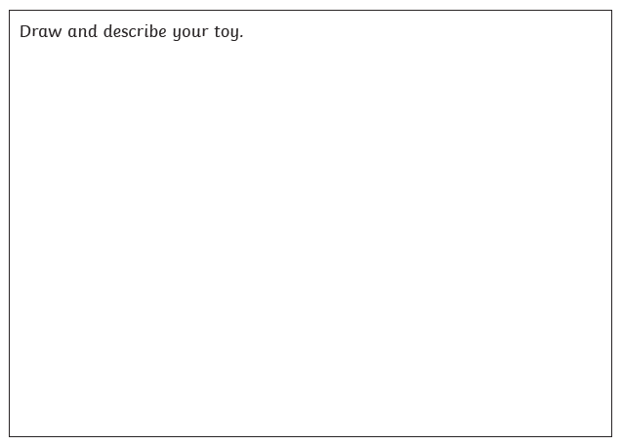
Compare how different things move.

LO: To understand movement, forces and magnets.
C: Notice and describe how things move using simple comparisons such as faster and slower.
Compare how different things move.

