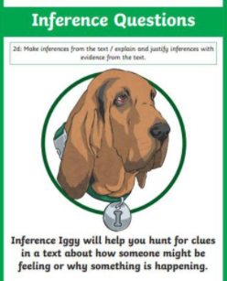
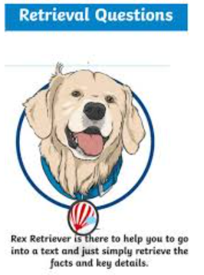
Tuesday 16th March 2021
L.O: To understand texts- inference skills
C: Boy
Today we continued to read our new book, and used our reading dogs skills to answer these questions.
- How much are the Sherbet Suckers? (1 mark)
- How do we know the boy is curious? What clues can you find in the text? (2 marks)
- Which sweet would you choose and why? (2 marks)
Tuesday 16th March 2021
L.O: To understand texts- inference skills
C: Boy
Today we continued to read our new book, and used our reading dogs skills to answer these questions.
- How much are the Sherbet Suckers? (1 mark)
- How do we know the boy is curious? What clues can you find in the text? (2 marks)
- Which sweet would you choose and why? (2 marks)
Tuesday 16th March 2021
L.O: To understand texts- inference skills
C: Boy
Today we continued to read our new book, and used our reading dogs skills to answer these questions.
- How much are the Sherbet Suckers? (1 mark)
- How do we know the boy is curious? What clues can you find in the text? (2 marks)
- Which sweet would you choose and why? (2 marks)
Tuesday 16th March 2021
L.O: To understand texts- inference skills
C: Boy
Today we continued to read our new book, and used our reading dogs skills to answer these questions.
- How much are the Sherbet Suckers? (1 mark)
- How do we know the boy is curious? What clues can you find in the text? (2 marks)
- Which sweet would you choose and why? (2 marks)

