Mega Movers
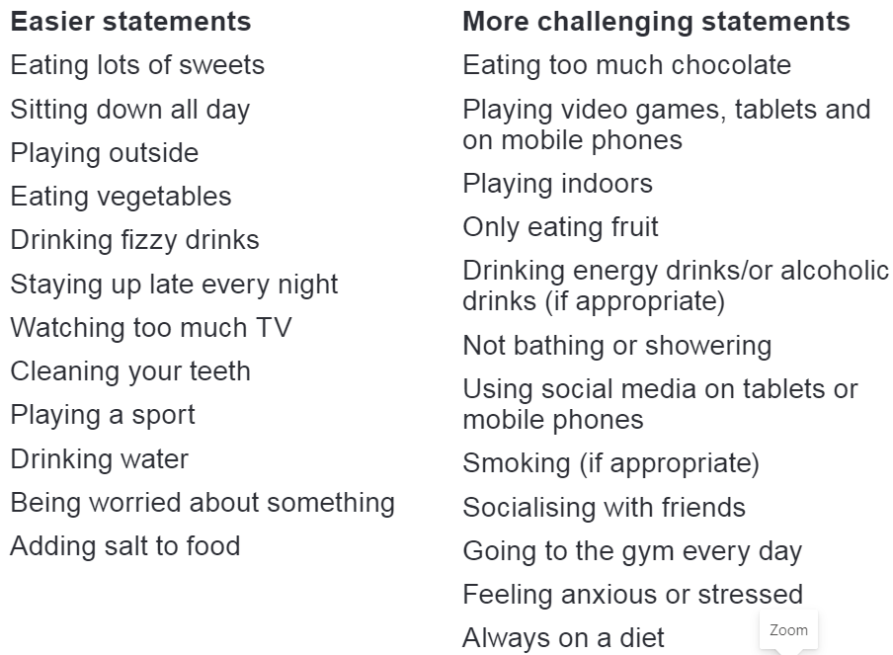

Decide whether these statements are healthy or not.

- Draw a bubble map to show different ways you can keep healthy.

- Decide whether you think these statements are true or false. The answers are on the website for you to check and find out some interesting facts afterwards.

- The brain makes enough electricity to power a small light bulb.
- Eating chocolate makes the brain work faster.
- A human brain sends more messages everyday than all the mobile phones in the world.
- We can train our brains to work better.
- If a part of our brain gets damaged or broken, it can never repair itself.
- Humans only use 1/10 (a tiny part) of their brains.
- Exercise like Mega Movers can help the brain to manage our feelings.
- Taking part in Mega Movers can help people learn better, for example get better at reading or Maths.

- Can you come up with a Mega Movers exercise routine, putting a series of movements together. This will be good for your body and brain. You could teach it to a friend or someone in your family.

