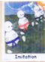
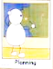

L. O. To take inspiration from the great
To master techniques
C: Portraits
Choose your favourite portrait. Use a magnifying glass and your noticing skills to draw parts of the Queen’s face.
Which is the hardest part of the Queen’s face to sketch? 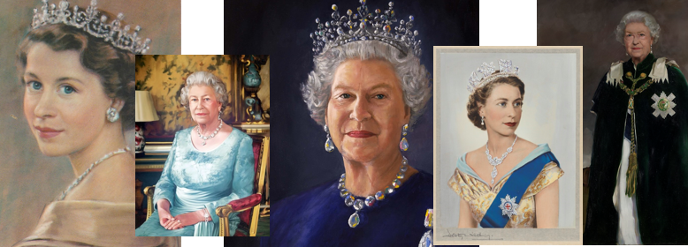

L. O. To take inspiration from the great
To master techniques
C: Portraits
Choose your favourite portrait. Use a magnifying glass and your noticing skills to draw parts of the Queen’s face.
Which is the hardest part of the Queen’s face to sketch?

