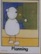

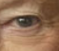
L.O. To take inspiration from the great To master techniques
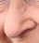
C: Portraits




