LO: Compare and contrast a small area of the UK and a contrasting non-European country.
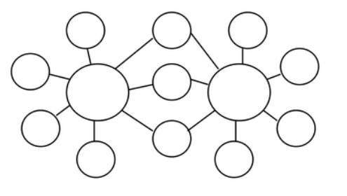
C: Understand geographical similarities and differences through studying the human and physical geography of a small area of the UK and a contrasting non-European country.

