https://royalcentral.co.uk/interests/residences/this-illustrated-map-shows-every-royal-residence-in-the-uk-132373/
1
2
3
4
5
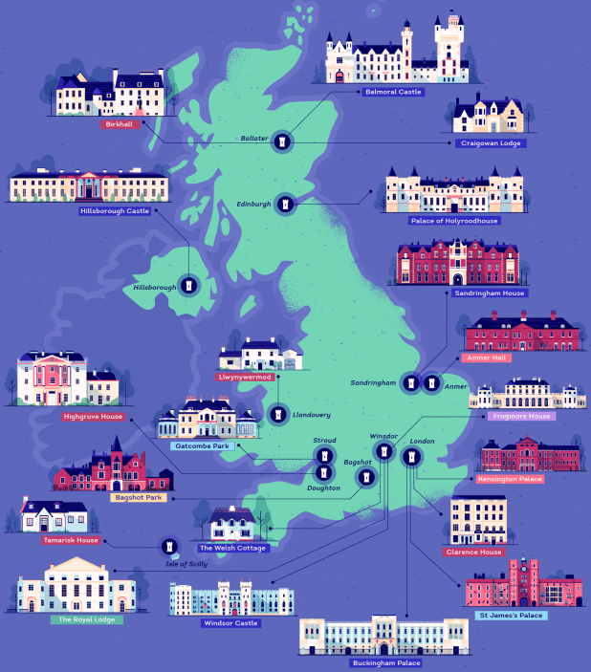
Find out 5 new facts about one of the Queen’s houses:

