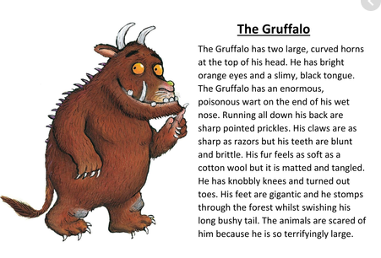
Can you find adjectives, verbs and similes?
How can this description help you with your writing?
Can you find adjectives, verbs and similes?
How can this description help you with your writing?

