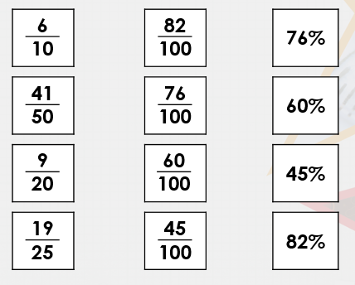
VF2  Shade the squares to show $\frac{7}{25}$ and write as a percentage | 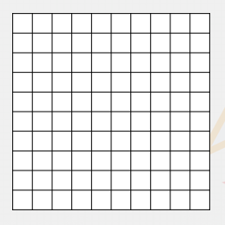
VF3 | Taj scored %  Bobby scored %  Reina scored %  Who gets to the final?
R1 | 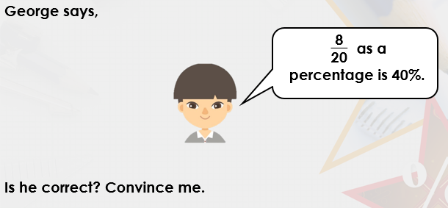
PS1 | The white area is %
PS2 | 

