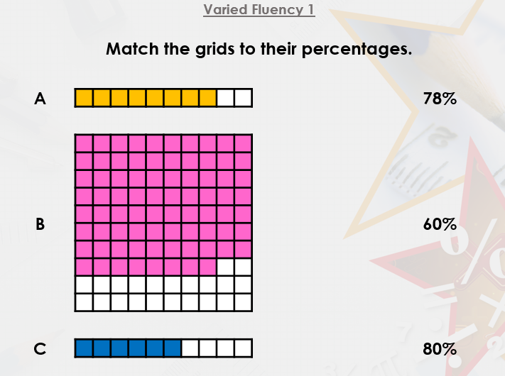
VF2 | A:  B:
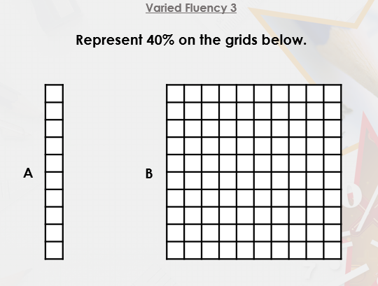
R1 | The odd one out is because
PS1 – Number the cards  1-6 (smallest to largest) | 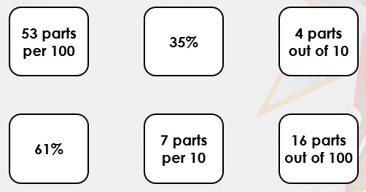
R2 | ……….. is correct because

