Q1.
Here are three symbols.
< > =
Write one symbol in each box to make the statements correct.
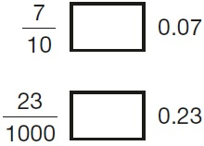
1 mark
Q2.
Circle the number that is equal to 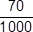
0.70 0.007 0.07 0.7
1 mark
Q3.

In each box, circle the number that is greater.

1.2

1.3

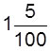 | 1.4

1.5
2 marks
Q4.

Write these numbers in order of size, starting with the smallest.
1.9 0.96 1.253 0.328

smallest
1 mark
Q5.

Here are five number cards.

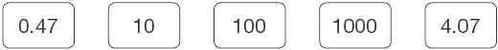
Use four of the cards to complete these calculations.

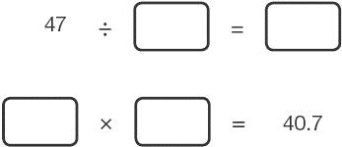
1 mark
Q6.Here are four digit cards.
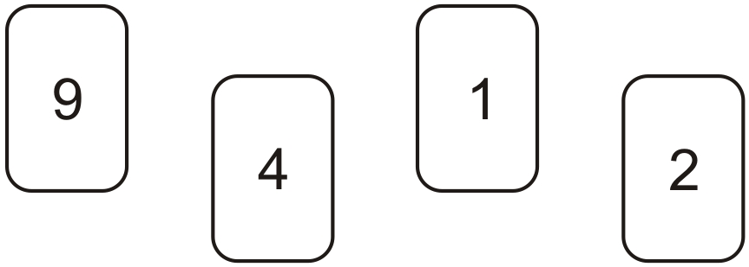
Use each digit card once to make the decimal number nearest to 20
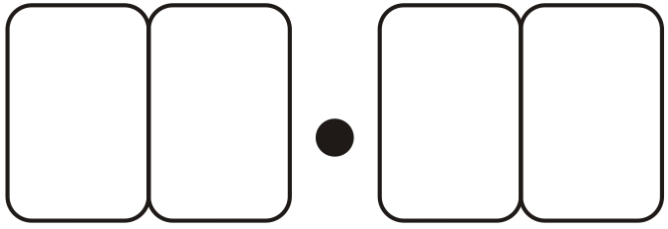
1 mark

[1]

