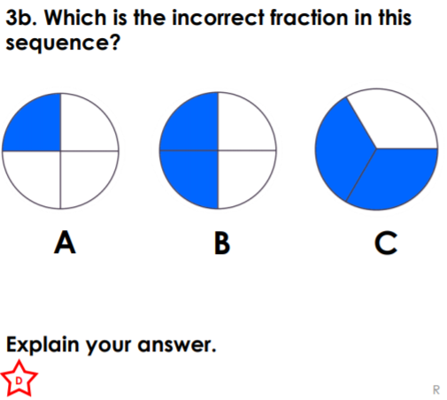
RPQ 2:
RPQ 2:
RPQ 2:
RPQ 2:
RPQ 2:
RPQ 2:

