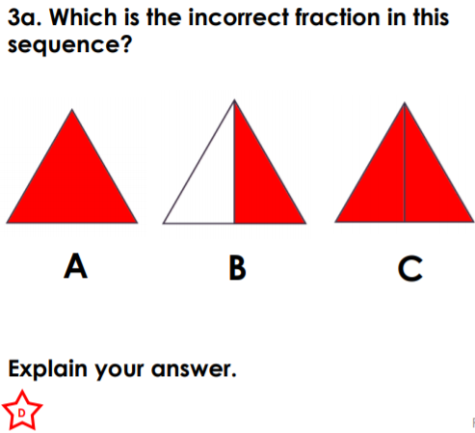
RPQ 1:
RPQ 1:
RPQ 1:
RPQ 1:
RPQ 1:
RPQ 1:

