 of 200 =
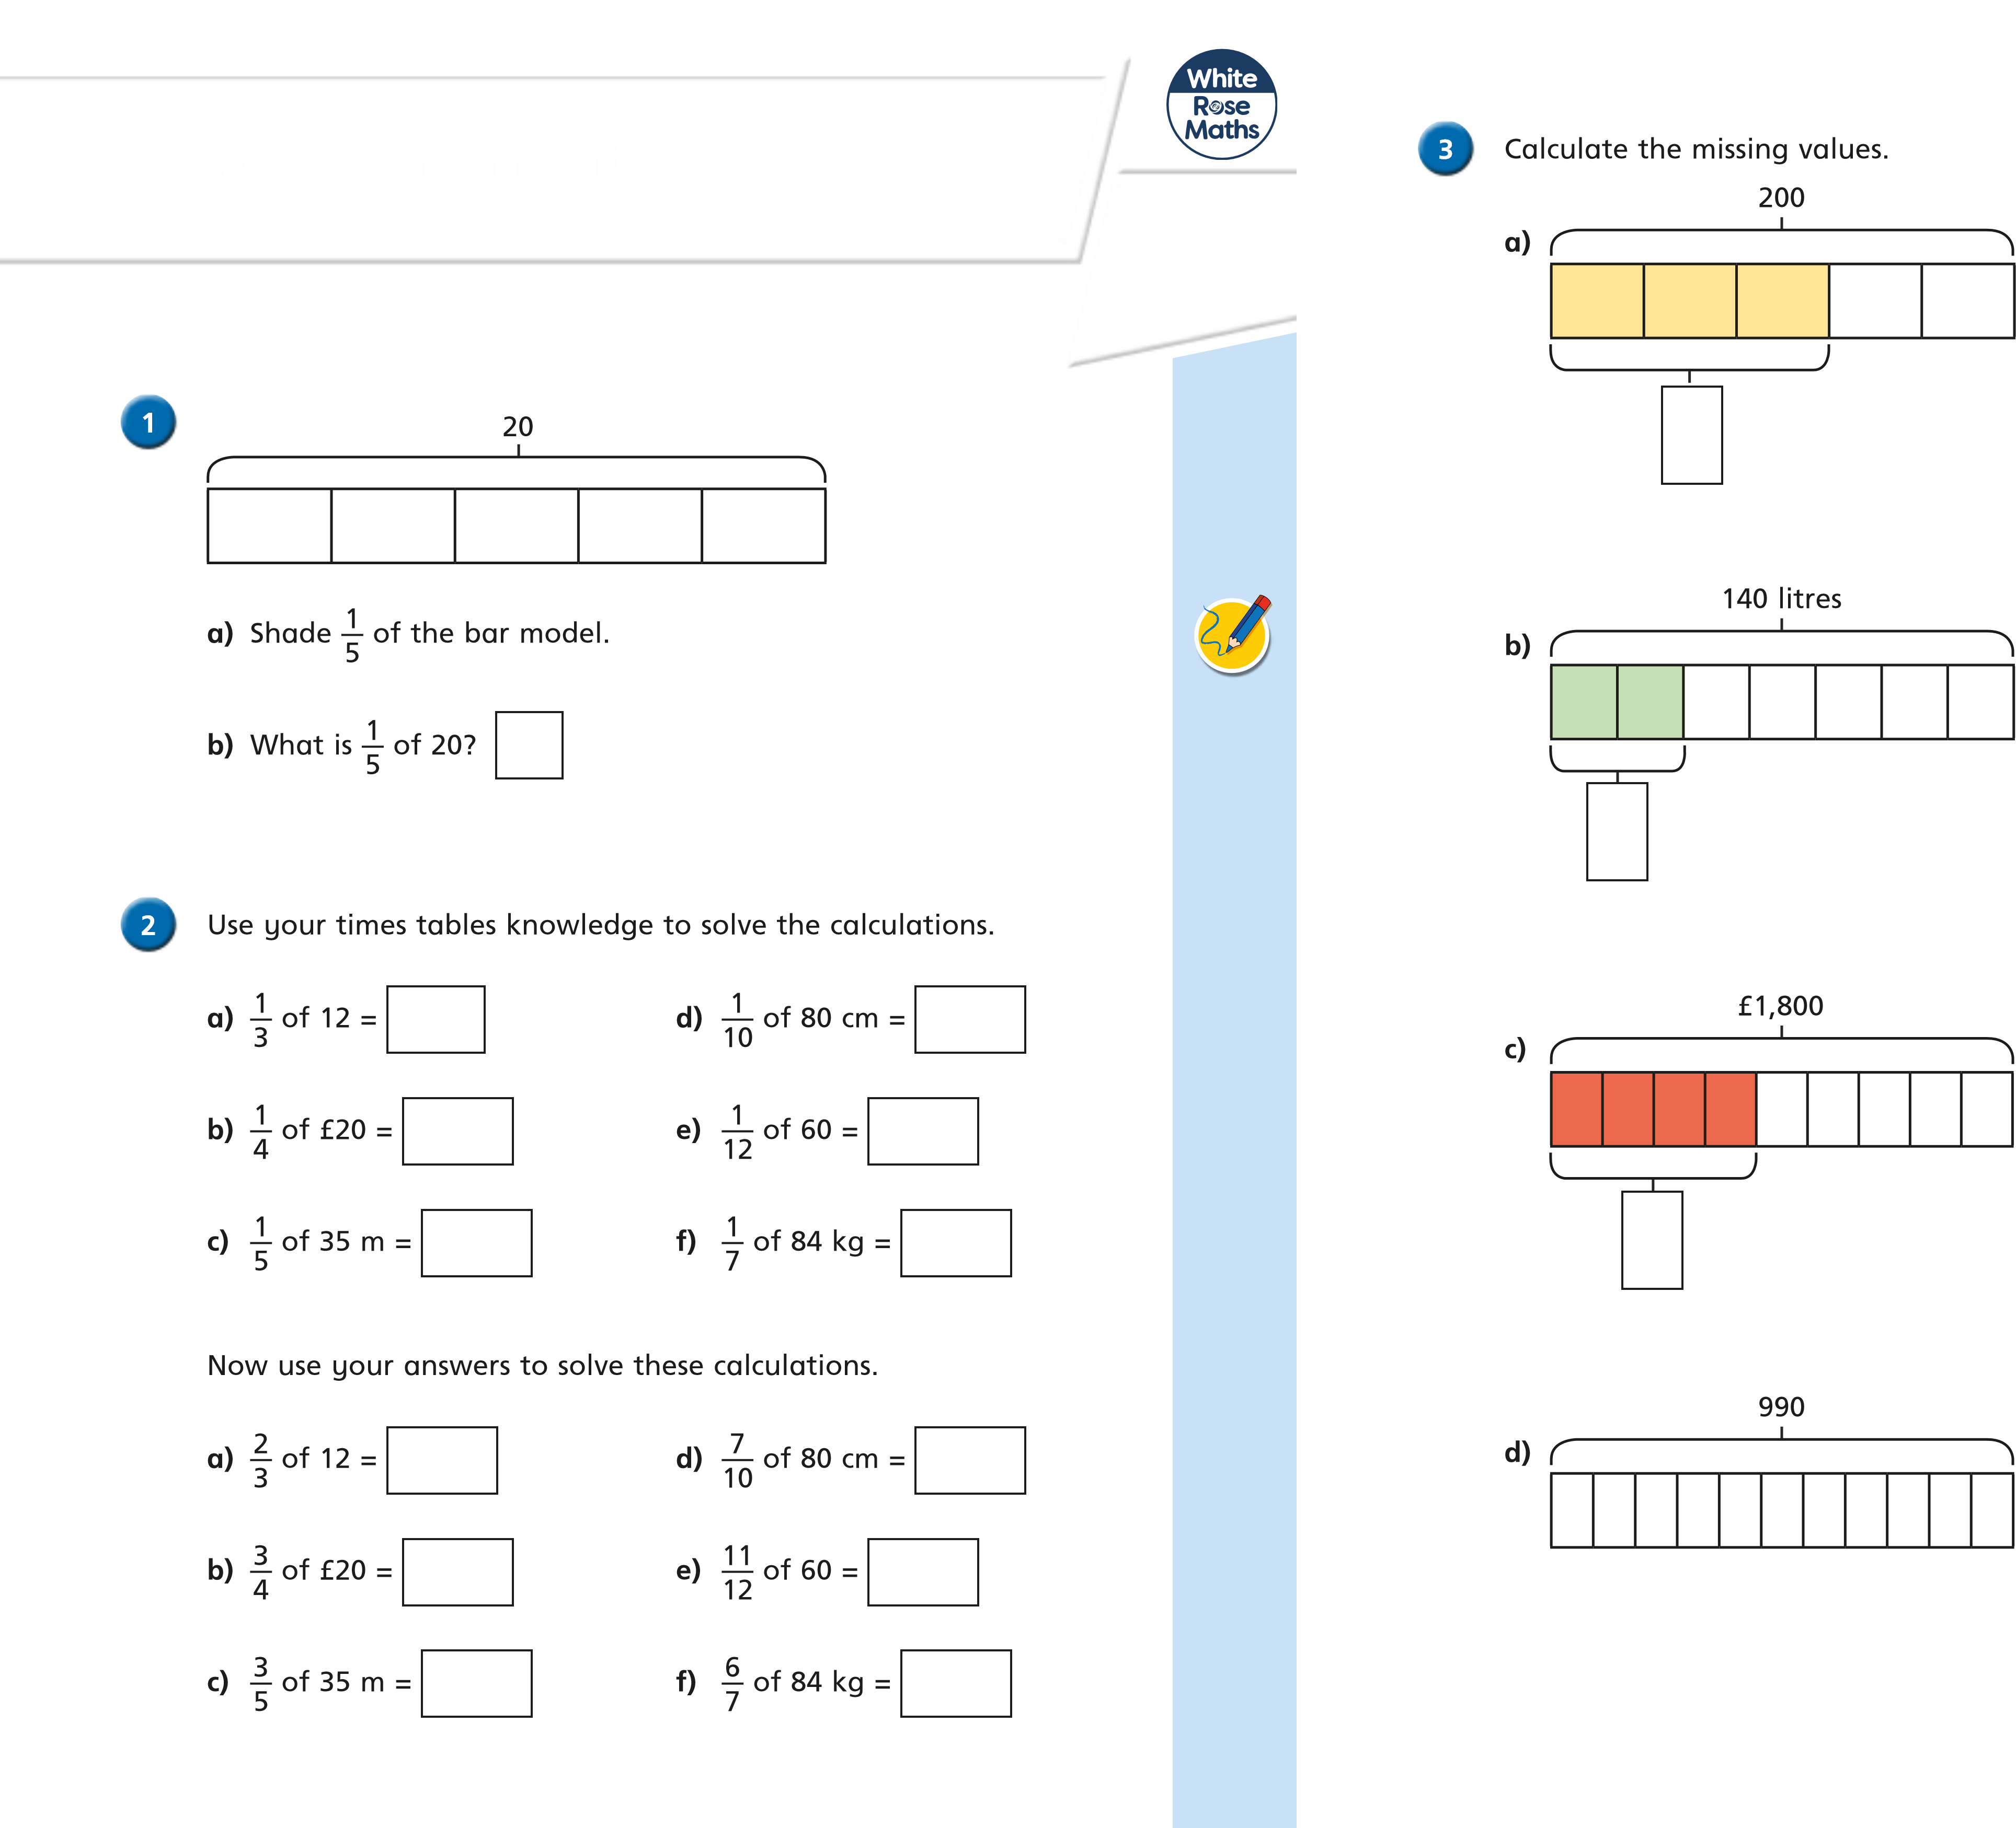

 of 140 litres =
 of £1,800 =
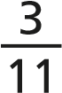 of 990 =
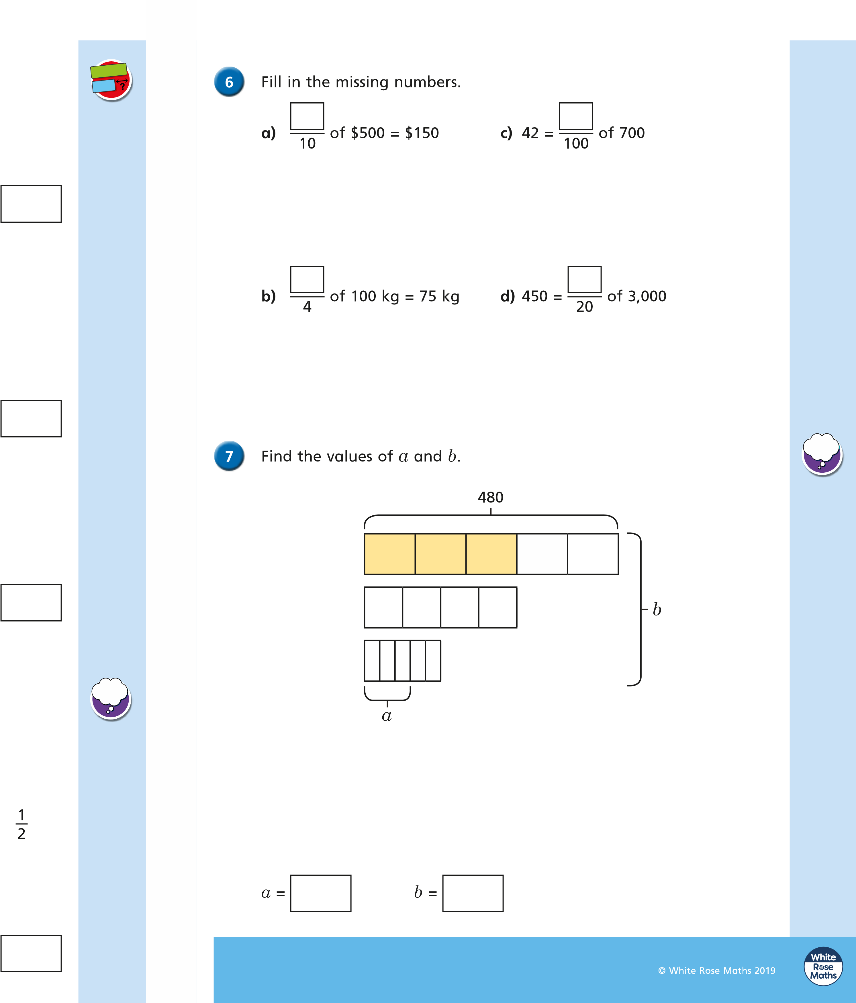
© White Rose Maths 2019
a)In a school of 480 pupils,  are juniors.
How many juniors are in the school?

- A factory makes 256 cars.  are electric cars.
How many electric cars does the factory make?

- Brett uses  of his £180 savings to buy a train ticket.
How much of his savings does he have left?

5

Alex has 288 m of fence to paint.
She paints  of the whole fence on Monday. She then paints of what is left on Tuesday.
How much fence does she have left to paint?

