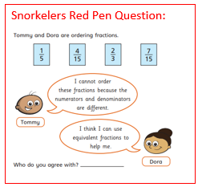
Snorkelers Red Pen Question:
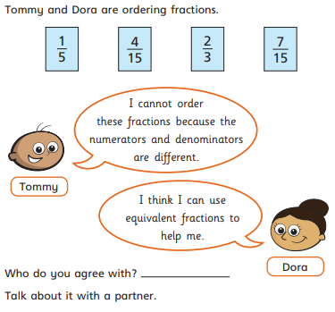
Snorkelers Red Pen Question:
Snorkelers Red Pen Question:

