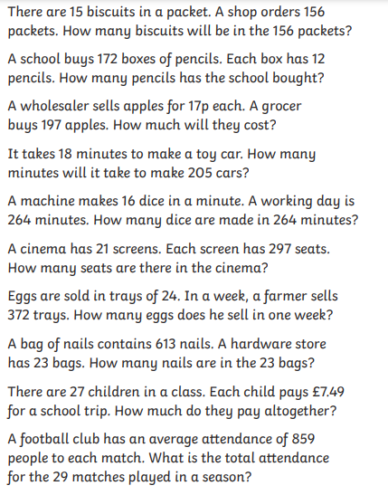

Red Pen: Choose one of the problems and write down how you know you are correct. Prove it!

