Thursday 1st July 2021 NFER Style Questions- retrieval - The Wild Way Home

Today we answered test style questions using the chapter “Run”.
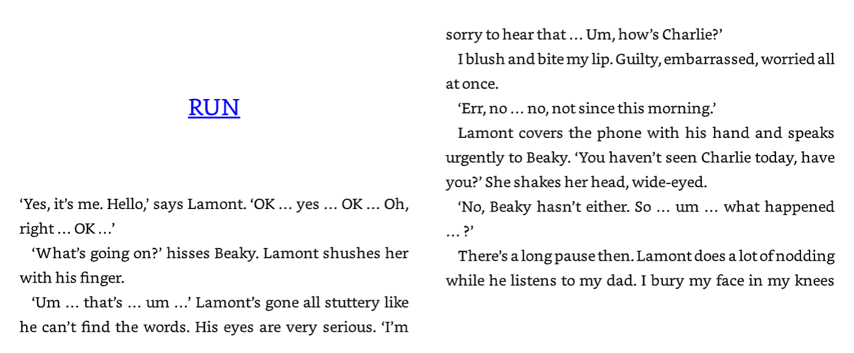
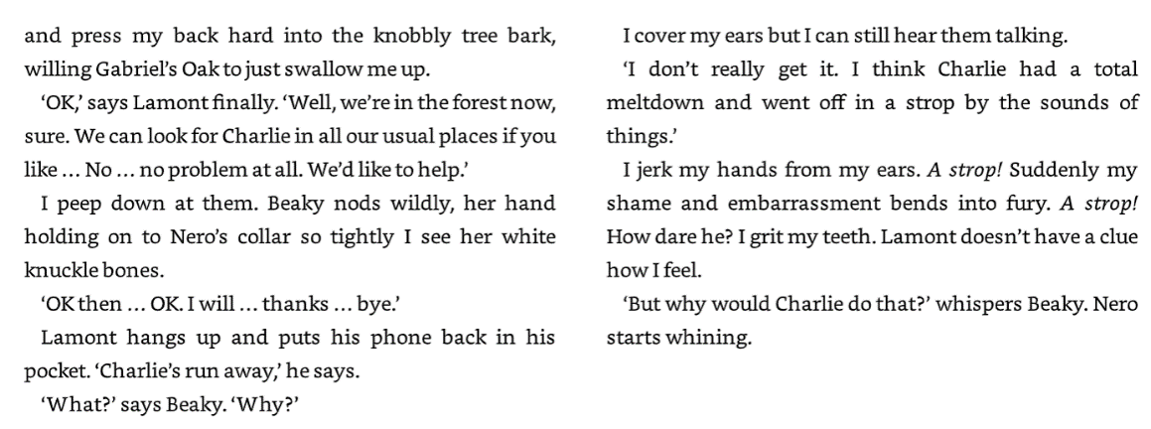

- Find and copy one word that tells you Lamont’s eyes are stern.

__________________ (1 mark)

- When Lamont says ‘How’s Charlie?’, Charlie feels three emotions. What are they?

_______________ _______________ _______________
(1 mark)

- What does Charlie say he hopes Gabriel’s tree will do to him?

____________________________________
(1 mark)

- What does Charlie do so that he does not have to listen to Lamont and Beaky talking?

____________________________________
(1 mark)

