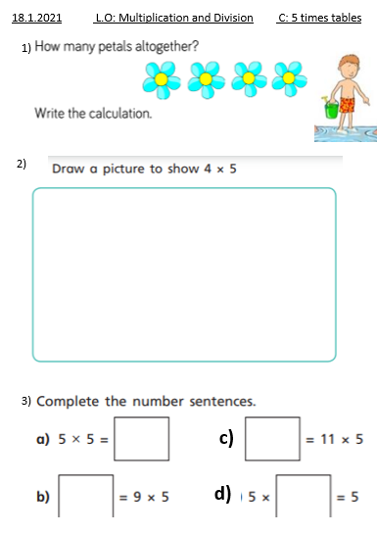
18.1.2021 L.O: Multiplication and Division C: 5 times tables
1)

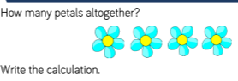
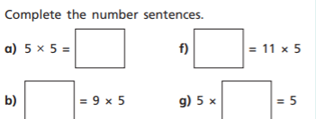
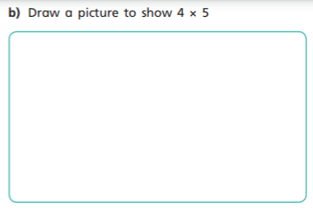
d)
c)
3)
2)

