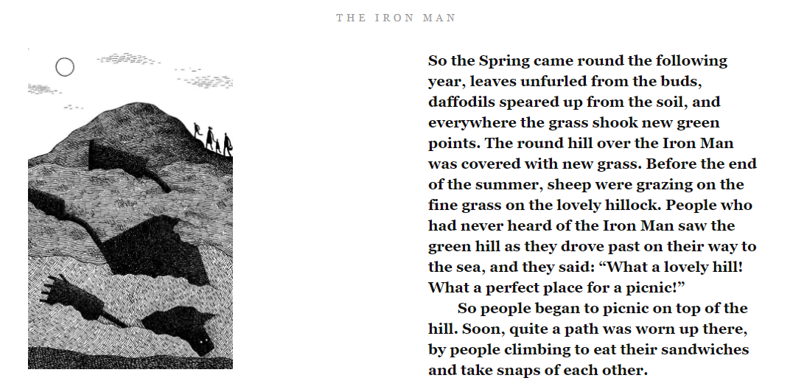

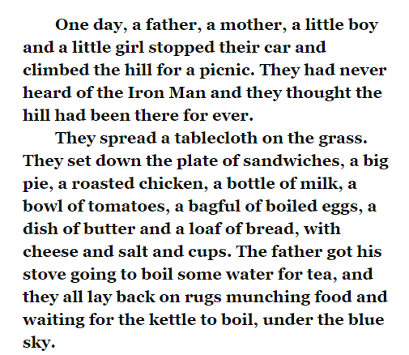
Task
Read the text and then draw a picture to go with the section you have read. Justify what you have drawn by using evidence from the text. E.g if you have a family climbing the hill, you may annotate that part of the picture with ‘one day, a father, a mother, a little boy and a little girl stopped their car and climbed the hill for a picnic.”

