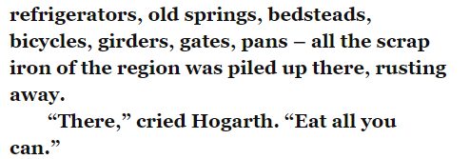
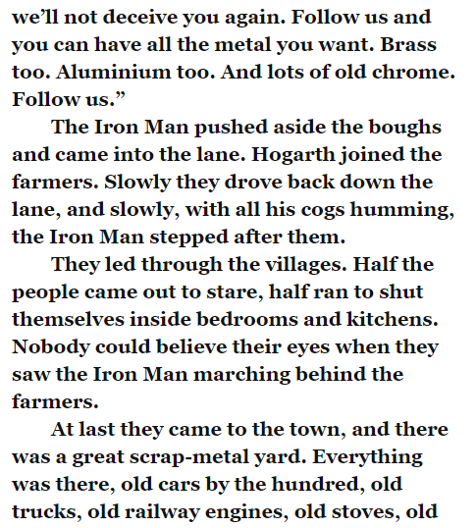
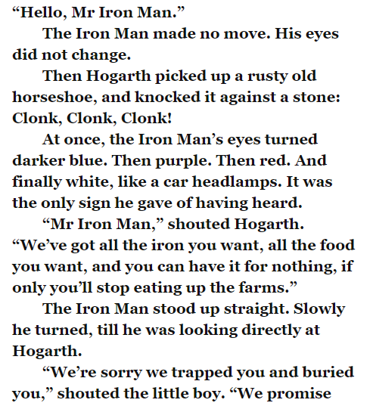
Read the text and answer the questions below.
- In the first paragraph, it say that the ‘Iron Man had no move’ when Hogarth spoke to him. However, when he hears the ‘clink, clink, clink’ his eyes change colour. Why does the Iron Man ignore Hogarth when he is speaking but react when he hears the ‘clink’ sound?
- The Iron Man follows Hogarth to the scrapyard after Hogarth promises not to deceive him again. Would you trust Hogarth if you were the Iron Man? Why/why not?

- the ‘clink’ sound?

